**EX N0:17 VEHICLE REGISTRATION SYSTEM**

**EDS CHAITANYA(192011372)**

**USE CASE DIAGRAM**

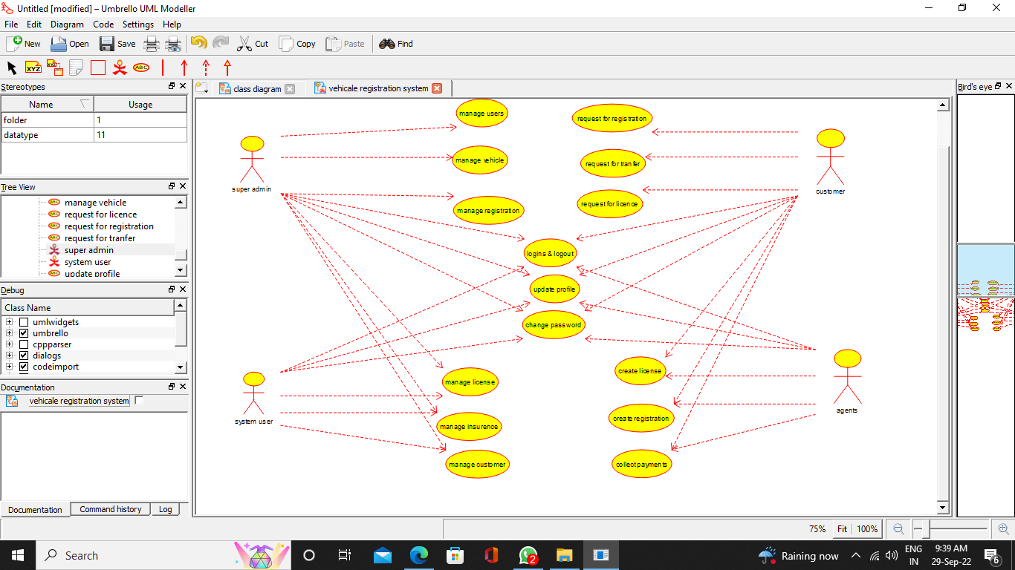

**CLASS DIAGRAM**

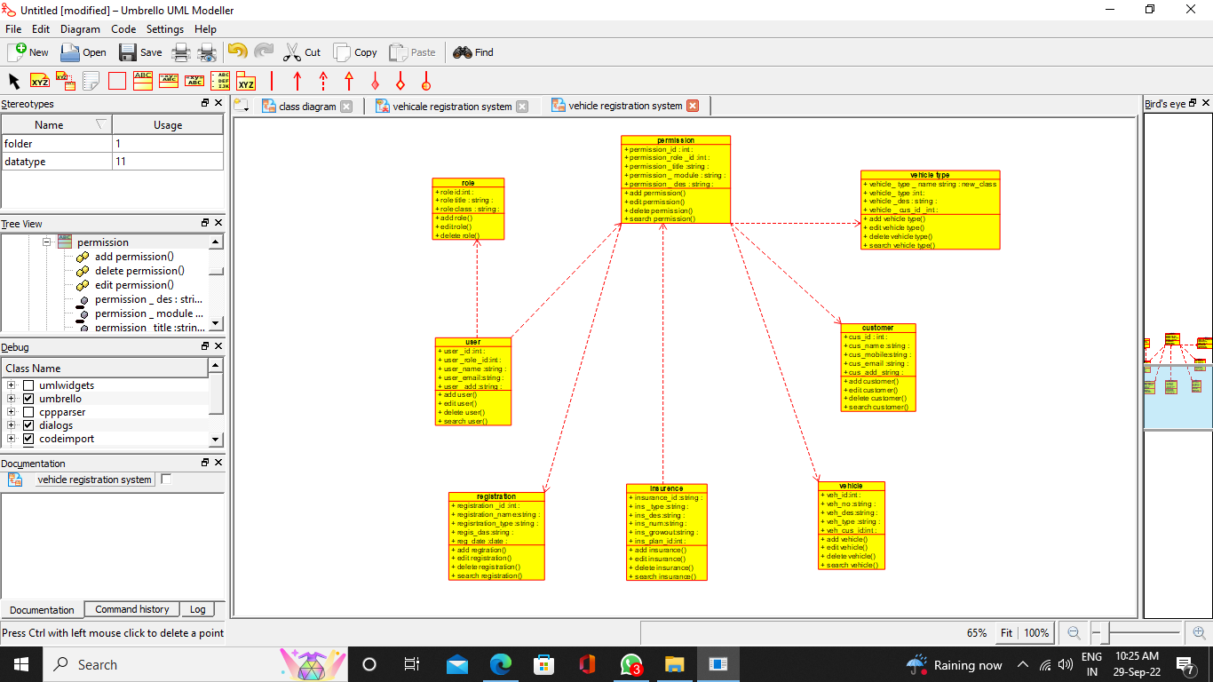

**ACTIVITY DIAGRAM**

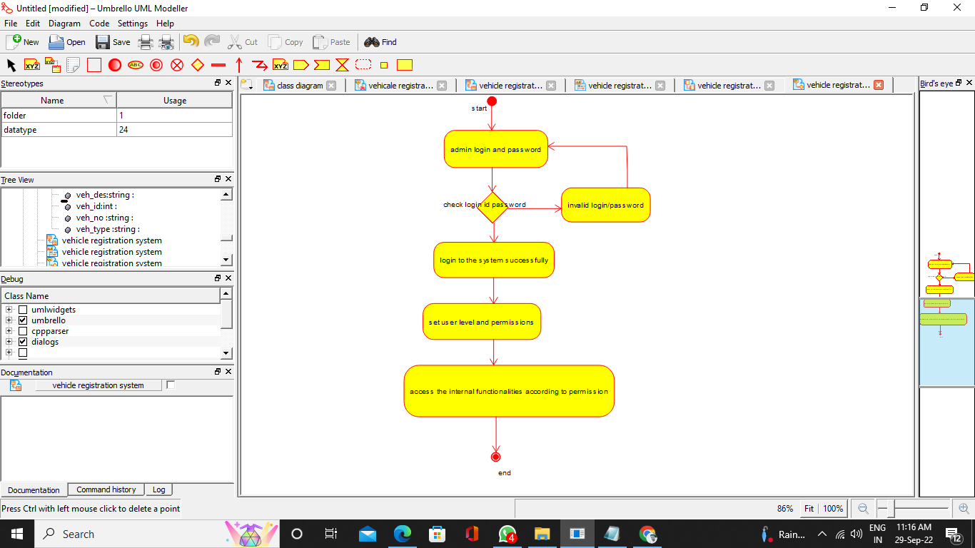

**SEQUENCE DIAGRAM**

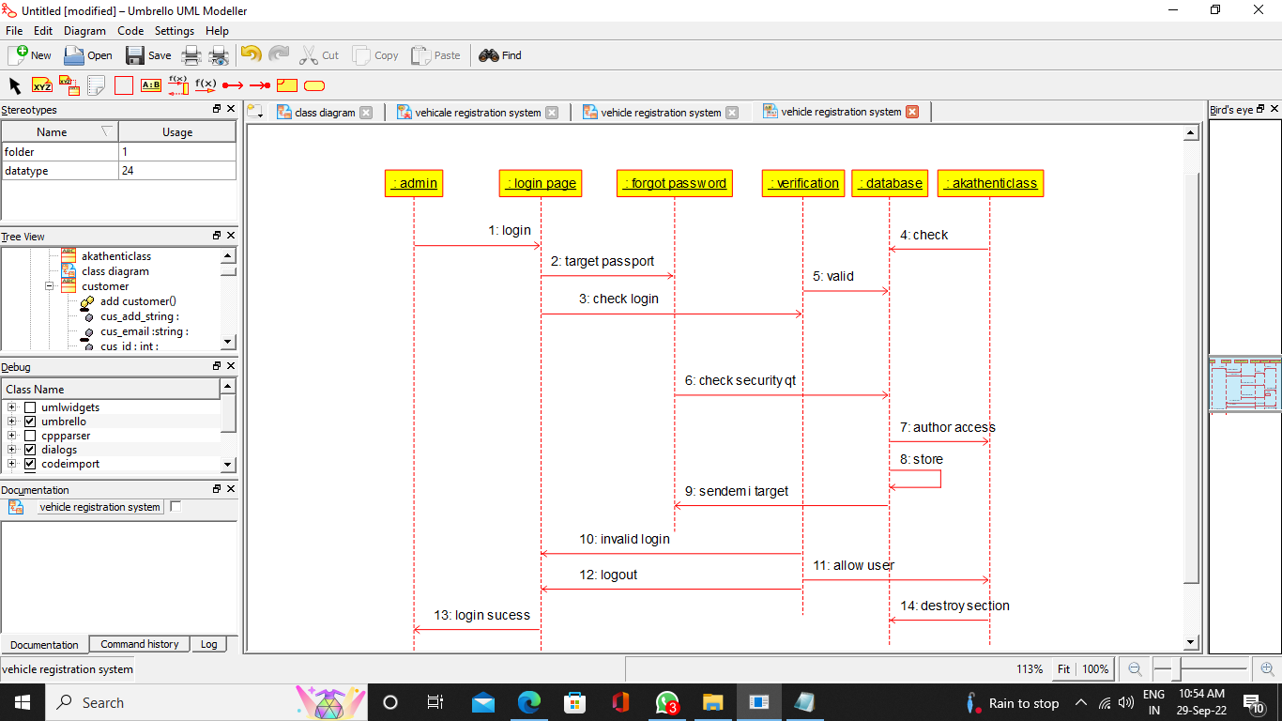

**COLLABORATION DIAGRAM**

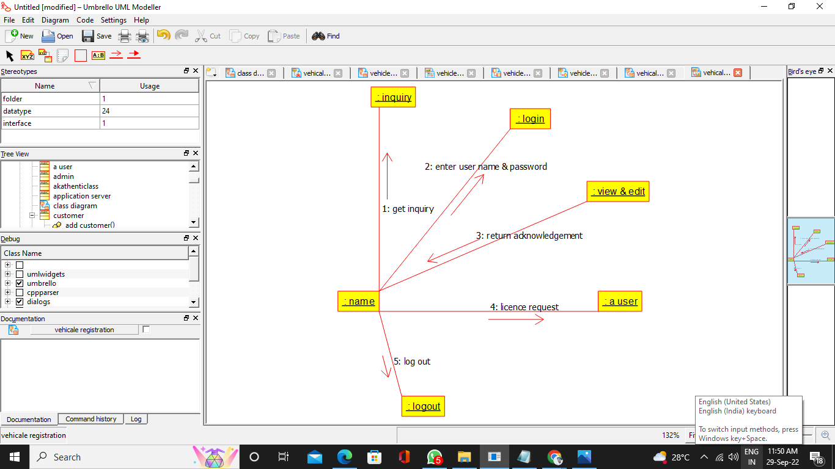

**COMPONENT DIAGRAM**

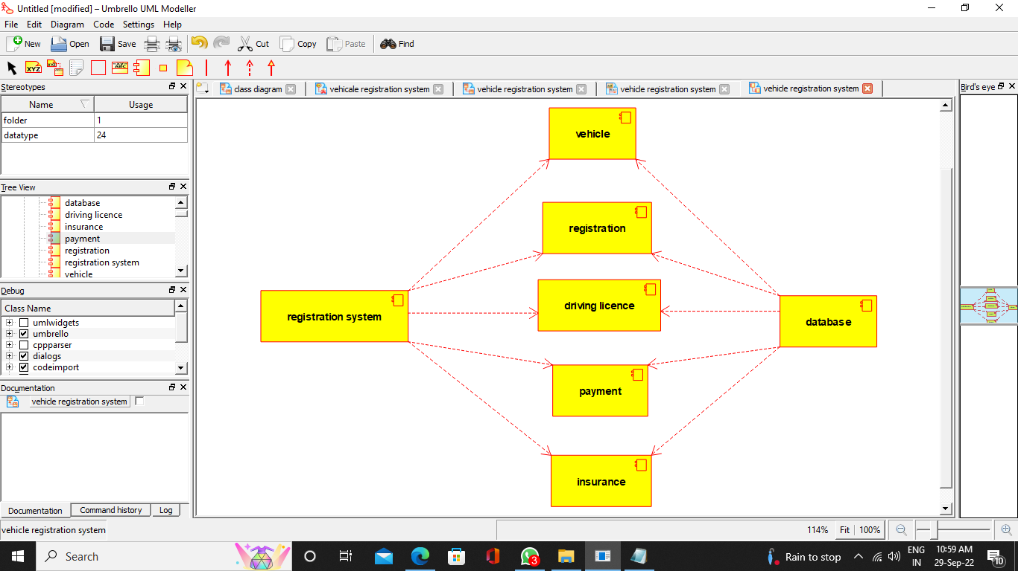

**DEPLOYMENT DIAGRAM**

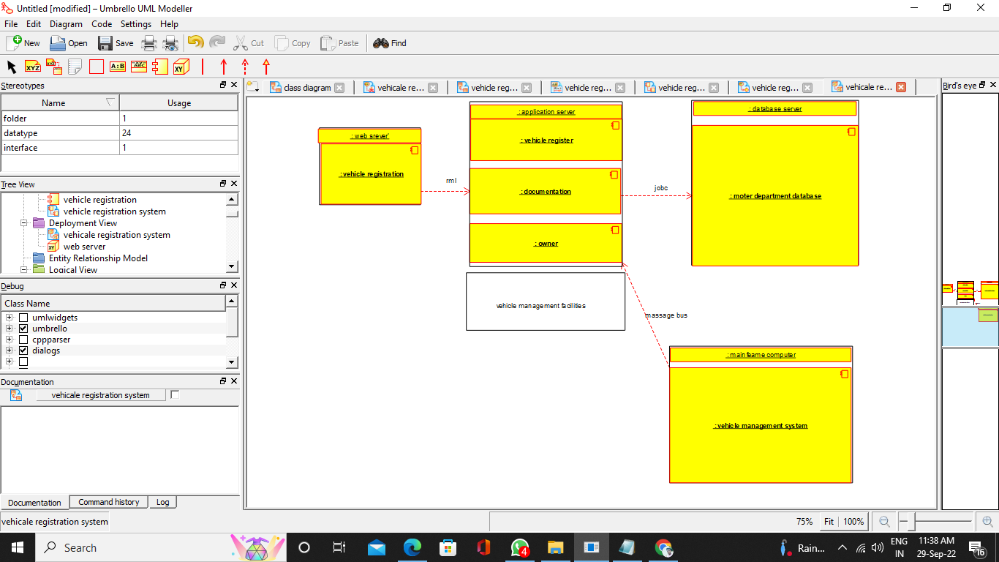

**PROGRAM CODE**

/**

* Class customer

*/

public class customer {

//

// Fields

//

public void cus_id_int;

public void cus_name_string;

public void cus_mobile_string;

public void cus_email_string;

public void cus_add_string;

//

// Constructors

//

public customer () { };

//

// Methods

//

//

// Accessor methods

//

/**

* Set the value of cus_id_int

* @param newVar the new value of cus_id_int

*/

public void setCus_id_int (void newVar) {

cus_id_int = newVar;

}

/**

* Get the value of cus_id_int

* @return the value of cus_id_int

*/

public void getCus_id_int () {

return cus_id_int;

}

/**

* Set the value of cus_name_string

* @param newVar the new value of cus_name_string

*/

public void setCus_name_string (void newVar) {

cus_name_string = newVar;

}

/**

* Get the value of cus_name_string

* @return the value of cus_name_string

*/

public void getCus_name_string () {

return cus_name_string;

}

/**

* Set the value of cus_mobile_string

* @param newVar the new value of cus_mobile_string

*/

public void setCus_mobile_string (void newVar) {

cus_mobile_string = newVar;

}

/**

* Get the value of cus_mobile_string

* @return the value of cus_mobile_string

*/

public void getCus_mobile_string () {

return cus_mobile_string;

}

/**

* Set the value of cus_email_string

* @param newVar the new value of cus_email_string

*/

public void setCus_email_string (void newVar) {

cus_email_string = newVar;

}

/**

* Get the value of cus_email_string

* @return the value of cus_email_string

*/

public void getCus_email_string () {

return cus_email_string;

}

/**

* Set the value of cus_add_string

* @param newVar the new value of cus_add_string

*/

public void setCus_add_string (void newVar) {

cus_add_string = newVar;

}

/**

* Get the value of cus_add_string

* @return the value of cus_add_string

*/

public void getCus_add_string () {

return cus_add_string;

}

//

// Other methods

//

/**

*/

public void add_customer()

{

}

/**

*/

public void edit_customer()

{

}

/**

*/

public void delete_customer()

{

}

/**

*/

public void search_customer()

{

}

}

/**

* Class insurence

*/

public class insurence {

//

// Fields

//

public void insurance_id_string;

public void ins__type_string;

public void ins_des_string;

public void ins_num_string;

public void ins_growout_string;

public void ins_plan_id_int;

//

// Constructors

//

public insurence () { };

//

// Methods

//

//

// Accessor methods

//

/**

* Set the value of insurance_id_string

* @param newVar the new value of insurance_id_string

*/

public void setInsurance_id_string (void newVar) {

insurance_id_string = newVar;

}

/**

* Get the value of insurance_id_string

* @return the value of insurance_id_string

*/

public void getInsurance_id_string () {

return insurance_id_string;

}

/**

* Set the value of ins__type_string

* @param newVar the new value of ins__type_string

*/

public void setIns__type_string (void newVar) {

ins__type_string = newVar;

}

/**

* Get the value of ins__type_string

* @return the value of ins__type_string

*/

public void getIns__type_string () {

return ins__type_string;

}

/**

* Set the value of ins_des_string

* @param newVar the new value of ins_des_string

*/

public void setIns_des_string (void newVar) {

ins_des_string = newVar;

}

/**

* Get the value of ins_des_string

* @return the value of ins_des_string

*/

public void getIns_des_string () {

return ins_des_string;

}

/**

* Set the value of ins_num_string

* @param newVar the new value of ins_num_string

*/

public void setIns_num_string (void newVar) {

ins_num_string = newVar;

}

/**

* Get the value of ins_num_string

* @return the value of ins_num_string

*/

public void getIns_num_string () {

return ins_num_string;

}

/**

* Set the value of ins_growout_string

* @param newVar the new value of ins_growout_string

*/

public void setIns_growout_string (void newVar) {

ins_growout_string = newVar;

}

/**

* Get the value of ins_growout_string

* @return the value of ins_growout_string

*/

public void getIns_growout_string () {

return ins_growout_string;

}

/**

* Set the value of ins_plan_id_int

* @param newVar the new value of ins_plan_id_int

*/

public void setIns_plan_id_int (void newVar) {

ins_plan_id_int = newVar;

}

/**

* Get the value of ins_plan_id_int

* @return the value of ins_plan_id_int

*/

public void getIns_plan_id_int () {

return ins_plan_id_int;

}

//

// Other methods

//

/**

*/

public void add_insurance()

{

}

/**

*/

public void edit_insurance()

{

}

/**

*/

public void delete_insurance()

{

}

/**

*/

public void search_insurance()

{

}

}

/**

* Class permission

*/

public class permission {

//

// Fields

//

public void permission_id_int;

public void permission_role__id_int;

public void permission__title_string;

public void permission___module_string;

public void permission___des_string;

//

// Constructors

//

public permission () { };

//

// Methods

//

//

// Accessor methods

//

/**

* Set the value of permission_id_int

* @param newVar the new value of permission_id_int

*/

public void setPermission_id_int (void newVar) {

permission_id_int = newVar;

}

/**

* Get the value of permission_id_int

* @return the value of permission_id_int

*/

public void getPermission_id_int () {

return permission_id_int;

}

/**

* Set the value of permission_role__id_int

* @param newVar the new value of permission_role__id_int

*/

public void setPermission_role__id_int (void newVar) {

permission_role__id_int = newVar;

}

/**

* Get the value of permission_role__id_int

* @return the value of permission_role__id_int

*/

public void getPermission_role__id_int () {

return permission_role__id_int;

}

/**

* Set the value of permission__title_string

* @param newVar the new value of permission__title_string

*/

public void setPermission__title_string (void newVar) {

permission__title_string = newVar;

}

/**

* Get the value of permission__title_string

* @return the value of permission__title_string

*/

public void getPermission__title_string () {

return permission__title_string;

}

/**

* Set the value of permission___module_string

* @param newVar the new value of permission___module_string

*/

public void setPermission___module_string (void newVar) {

permission___module_string = newVar;

}

/**

* Get the value of permission___module_string

* @return the value of permission___module_string

*/

public void getPermission___module_string () {

return permission___module_string;

}

/**

* Set the value of permission___des_string

* @param newVar the new value of permission___des_string

*/

public void setPermission___des_string (void newVar) {

permission___des_string = newVar;

}

/**

* Get the value of permission___des_string

* @return the value of permission___des_string

*/

public void getPermission___des_string () {

return permission___des_string;

}

//

// Other methods

//

/**

*/

public void add_permission()

{

}

/**

*/

public void edit_permission()

{

}

/**

*/

public void delete_permission()

{

}

/**

*/

public void search_permission()

{

}

}

/**

* Class registration

*/

public class registration {

//

// Fields

//

public void registration__id_int;

public void registration_name_string;

public void regisrtration_type_string;

public void regis_das_string;

public void reg_date_date;

//

// Constructors

//

public registration () { };

//

// Methods

//

//

// Accessor methods

//

/**

* Set the value of registration__id_int

* @param newVar the new value of registration__id_int

*/

public void setRegistration__id_int (void newVar) {

registration__id_int = newVar;

}

/**

* Get the value of registration__id_int

* @return the value of registration__id_int

*/

public void getRegistration__id_int () {

return registration__id_int;

}

/**

* Set the value of registration_name_string

* @param newVar the new value of registration_name_string

*/

public void setRegistration_name_string (void newVar) {

registration_name_string = newVar;

}

/**

* Get the value of registration_name_string

* @return the value of registration_name_string

*/

public void getRegistration_name_string () {

return registration_name_string;

}

/**

* Set the value of regisrtration_type_string

* @param newVar the new value of regisrtration_type_string

*/

public void setRegisrtration_type_string (void newVar) {

regisrtration_type_string = newVar;

}

/**

* Get the value of regisrtration_type_string

* @return the value of regisrtration_type_string

*/

public void getRegisrtration_type_string () {

return regisrtration_type_string;

}

/**

* Set the value of regis_das_string

* @param newVar the new value of regis_das_string

*/

public void setRegis_das_string (void newVar) {

regis_das_string = newVar;

}

/**

* Get the value of regis_das_string

* @return the value of regis_das_string

*/

public void getRegis_das_string () {

return regis_das_string;

}

/**

* Set the value of reg_date_date

* @param newVar the new value of reg_date_date

*/

public void setReg_date_date (void newVar) {

reg_date_date = newVar;

}

/**

* Get the value of reg_date_date

* @return the value of reg_date_date

*/

public void getReg_date_date () {

return reg_date_date;

}

//

// Other methods

//

/**

*/

public void add_regtration()

{

}

/**

*/

public void edit_registration()

{

}

/**

*/

public void delete_registration()

{

}

/**

*/

public void search_registration()

{

}

}

/**

* Class role

*/

public class role {

//

// Fields

//

public void role_id_int;

public void role_title_string;

public void role_class_string;

//

// Constructors

//

public role () { };

//

// Methods

//

//

// Accessor methods

//

/**

* Set the value of role_id_int

* @param newVar the new value of role_id_int

*/

public void setRole_id_int (void newVar) {

role_id_int = newVar;

}

/**

* Get the value of role_id_int

* @return the value of role_id_int

*/

public void getRole_id_int () {

return role_id_int;

}

/**

* Set the value of role_title_string

* @param newVar the new value of role_title_string

*/

public void setRole_title_string (void newVar) {

role_title_string = newVar;

}

/**

* Get the value of role_title_string

* @return the value of role_title_string

*/

public void getRole_title_string () {

return role_title_string;

}

/**

* Set the value of role_class_string

* @param newVar the new value of role_class_string

*/

public void setRole_class_string (void newVar) {

role_class_string = newVar;

}

/**

* Get the value of role_class_string

* @return the value of role_class_string

*/

public void getRole_class_string () {

return role_class_string;

}

//

// Other methods

//

/**

*/

public void add_role()

{

}

/**

*/

public void edit_role()

{

}

/**

*/

public void delete_role()

{

}

}

/**

* Class user

*/

public class user {

//

// Fields

//

public void user__id_int;

public void user__role__id_int;

public void user_name_string;

public void user_email_string;

public void user__add_string;

//

// Constructors

//

public user () { };

//

// Methods

//

//

// Accessor methods

//

/**

* Set the value of user__id_int

* @param newVar the new value of user__id_int

*/

public void setUser__id_int (void newVar) {

user__id_int = newVar;

}

/**

* Get the value of user__id_int

* @return the value of user__id_int

*/

public void getUser__id_int () {

return user__id_int;

}

/**

* Set the value of user__role__id_int

* @param newVar the new value of user__role__id_int

*/

public void setUser__role__id_int (void newVar) {

user__role__id_int = newVar;

}

/**

* Get the value of user__role__id_int

* @return the value of user__role__id_int

*/

public void getUser__role__id_int () {

return user__role__id_int;

}

/**

* Set the value of user_name_string

* @param newVar the new value of user_name_string

*/

public void setUser_name_string (void newVar) {

user_name_string = newVar;

}

/**

* Get the value of user_name_string

* @return the value of user_name_string

*/

public void getUser_name_string () {

return user_name_string;

}

/**

* Set the value of user_email_string

* @param newVar the new value of user_email_string

*/

public void setUser_email_string (void newVar) {

user_email_string = newVar;

}

/**

* Get the value of user_email_string

* @return the value of user_email_string

*/

public void getUser_email_string () {

return user_email_string;

}

/**

* Set the value of user__add_string

* @param newVar the new value of user__add_string

*/

public void setUser__add_string (void newVar) {

user__add_string = newVar;

}

/**

* Get the value of user__add_string

* @return the value of user__add_string

*/

public void getUser__add_string () {

return user__add_string;

}

//

// Other methods

//

/**

*/

public void add_user()

{

}

/**

*/

public void edit_user()

{

}

/**

*/

public void delete_user()

{

}

/**

*/

public void search_user()

{

}

}

/**

* Class vehicle_type

*/

public class vehicle_type {

//

// Fields

//

public new_class vehicle__type___name_string;

public void vehicle__type_int;

public void vehicle__des_string;

public void vehicle___cus_id__int;

//

// Constructors

//

public vehicle_type () { };

//

// Methods

//

//

// Accessor methods

//

/**

* Set the value of vehicle__type___name_string

* @param newVar the new value of vehicle__type___name_string

*/

public void setVehicle__type___name_string (new_class newVar) {

vehicle__type___name_string = newVar;

}

/**

* Get the value of vehicle__type___name_string

* @return the value of vehicle__type___name_string

*/

public new_class getVehicle__type___name_string () {

return vehicle__type___name_string;

}

/**

* Set the value of vehicle__type_int

* @param newVar the new value of vehicle__type_int

*/

public void setVehicle__type_int (void newVar) {

vehicle__type_int = newVar;

}

/**

* Get the value of vehicle__type_int

* @return the value of vehicle__type_int

*/

public void getVehicle__type_int () {

return vehicle__type_int;

}

/**

* Set the value of vehicle__des_string

* @param newVar the new value of vehicle__des_string

*/

public void setVehicle__des_string (void newVar) {

vehicle__des_string = newVar;

}

/**

* Get the value of vehicle__des_string

* @return the value of vehicle__des_string

*/

public void getVehicle__des_string () {

return vehicle__des_string;

}

/**

* Set the value of vehicle___cus_id__int

* @param newVar the new value of vehicle___cus_id__int

*/

public void setVehicle___cus_id__int (void newVar) {

vehicle___cus_id__int = newVar;

}

/**

* Get the value of vehicle___cus_id__int

* @return the value of vehicle___cus_id__int

*/

public void getVehicle___cus_id__int () {

return vehicle___cus_id__int;

}

//

// Other methods

//

/**

*/

public void add_vehicle_type()

{

}

/**

*/

public void edit_vehicle_type()

{

}

/**

*/

public void delete_vehicle_type()

{

}

/**

*/

public void search_vehicle_type()

{

}

}

**EX NO: 18 FOOD ORDERING SYSTEM**

**USECASE DIAGRAM :-**

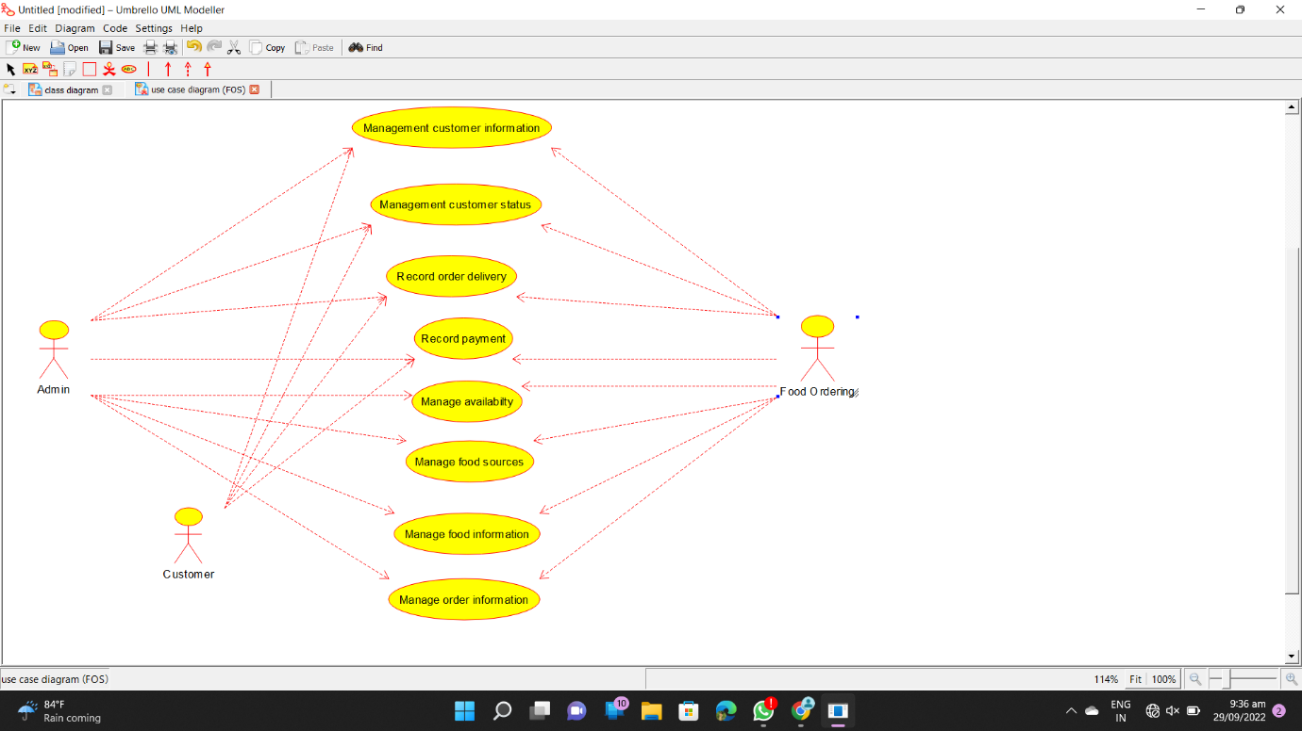

**CLASS DIAGRAM :-**

‘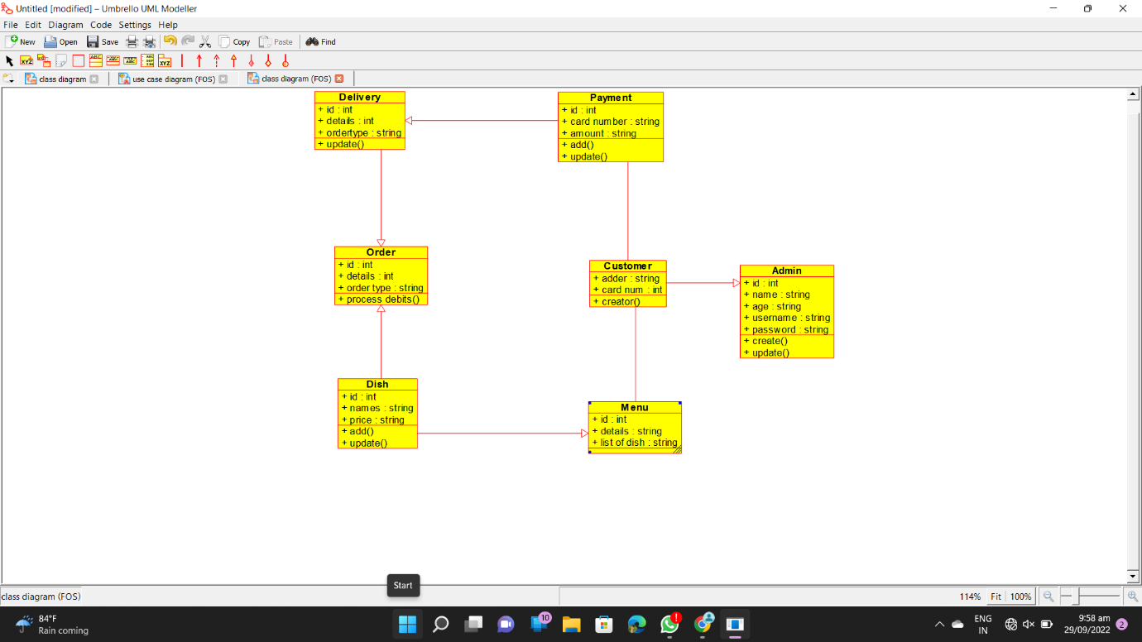

**SEQUENCE DIAGRAM :-**

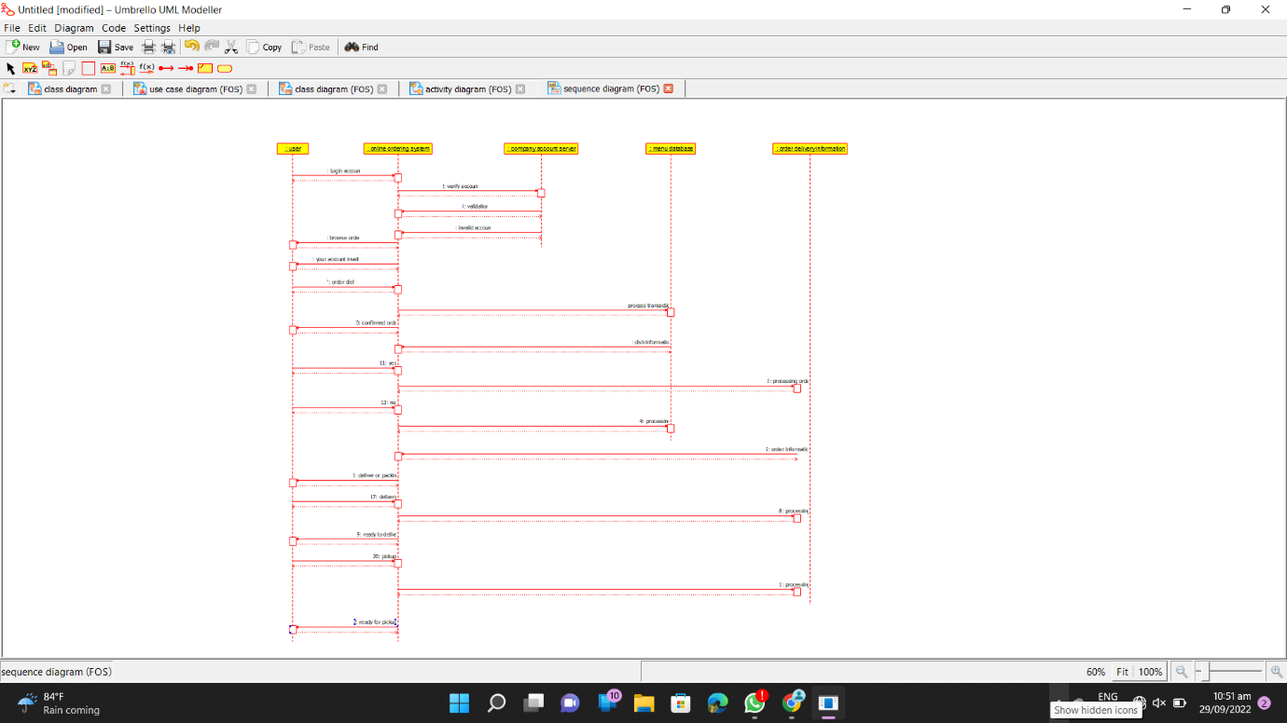

**COLLABORATION DIAGRAM :-**

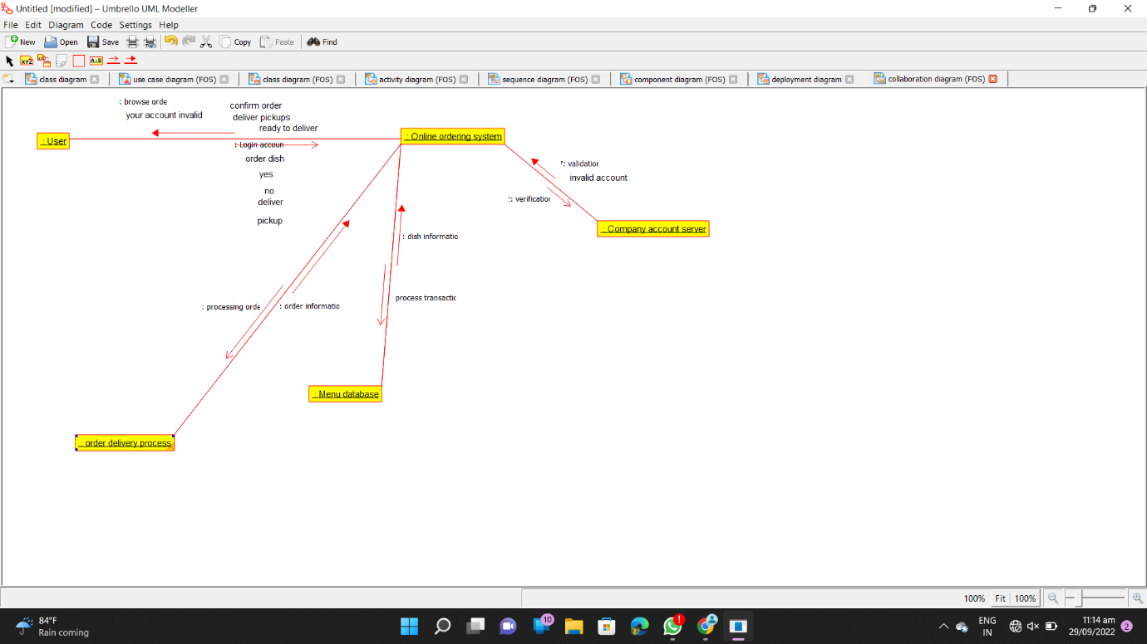

**COMPONENT DIAGRAM :-**

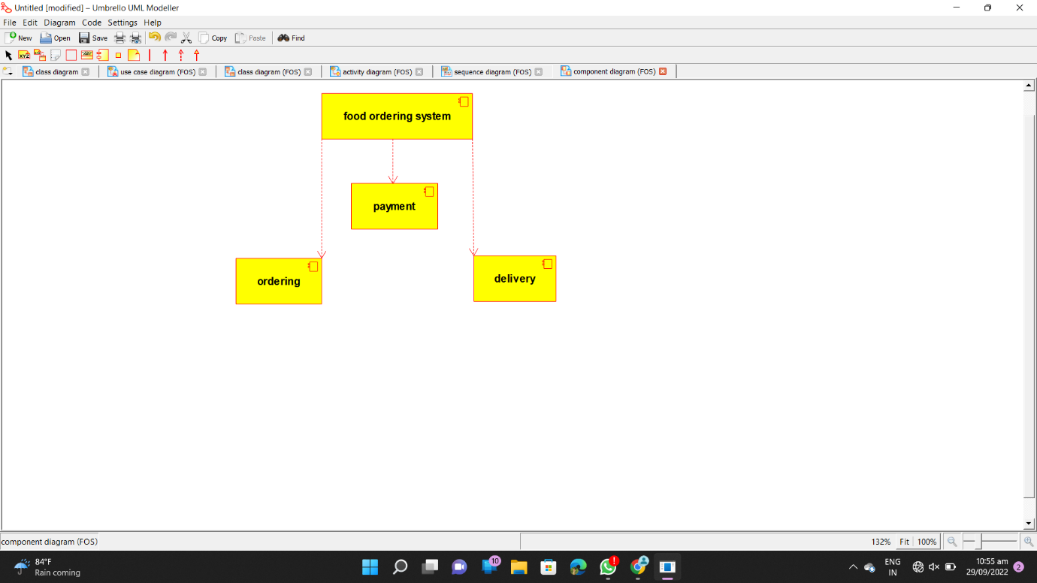

**DEPLOYMENT DIAGRAM :-**

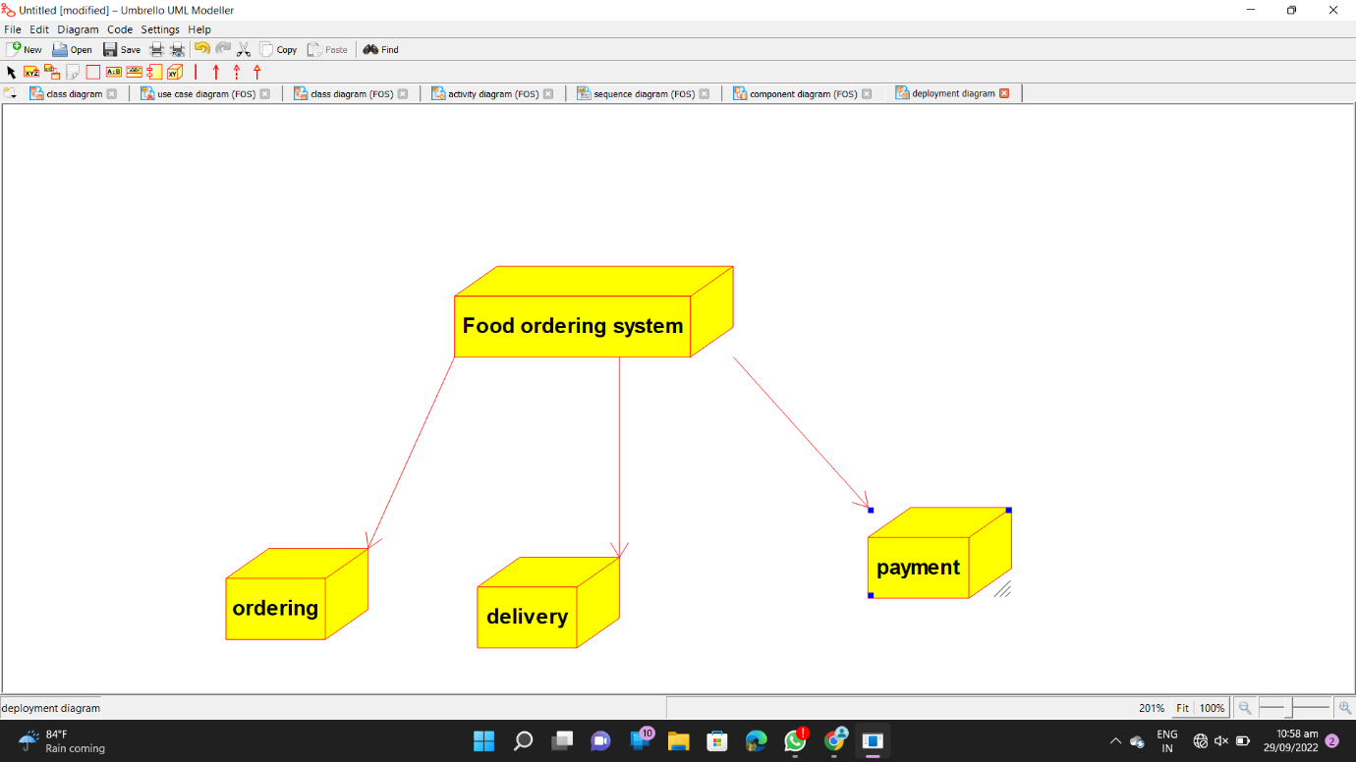

**PROGRAM CODE :-**

/**

* Class Admin

*/

public class Admin {

//

// Fields

//

public int id;

public String name;

public String age;

public String username;

public String password;

//

// Constructors

//

public Admin () { };

//

// Methods

//

//

// Accessor methods

//

/**

* Set the value of id

* @param newVar the new value of id

*/

public void setId (int newVar) {

id = newVar;

}

/**

* Get the value of id

* @return the value of id

*/

public int getId () {

return id;

}

/**

* Set the value of name

* @param newVar the new value of name

*/

public void setName (String newVar) {

name = newVar;

}

/**

* Get the value of name

* @return the value of name

*/

public String getName () {

return name;

}

/**

* Set the value of age

* @param newVar the new value of age

*/

public void setAge (String newVar) {

age = newVar;

}

/**

* Get the value of age

* @return the value of age

*/

public String getAge () {

return age;

}

/**

* Set the value of username

* @param newVar the new value of username

*/

public void setUsername (String newVar) {

username = newVar;

}

/**

* Get the value of username

* @return the value of username

*/

public String getUsername () {

return username;

}

/**

* Set the value of password

* @param newVar the new value of password

*/

public void setPassword (String newVar) {

password = newVar;

}

/**

* Get the value of password

* @return the value of password

*/

public String getPassword () {

return password;

}

//

// Other methods

//

/**

*/

public void create()

{

}

/**

*/

public void update()

{

}

}

import java.util.*;

/**

* Class Customer

*/

public class Customer extends Admin {

//

// Fields

//

public String adder;

public int card_num;

//

// Constructors

//

public Customer () { };

//

// Methods

//

//

// Accessor methods

//

/**

* Set the value of adder

* @param newVar the new value of adder

*/

public void setAdder (String newVar) {

adder = newVar;

}

/**

* Get the value of adder

* @return the value of adder

*/

public String getAdder () {

return adder;

}

/**

* Set the value of card_num

* @param newVar the new value of card_num

*/

public void setCard_num (int newVar) {

card_num = newVar;

}

/**

* Get the value of card_num

* @return the value of card_num

*/

public int getCard_num () {

return card_num;

}

//

// Other methods

//

/**

*/

public void creator()

{

}

}

/**

* Class Delivery

*/

public class Delivery extends Order {

//

// Fields

//

public int id;

public int details;

public String ordertype;

//

// Constructors

//

public Delivery () { };

//

// Methods

//

//

// Accessor methods

//

/**

* Set the value of id

* @param newVar the new value of id

*/

public void setId (int newVar) {

id = newVar;

}

/**

* Get the value of id

* @return the value of id

*/

public int getId () {

return id;

}

/**

* Set the value of details

* @param newVar the new value of details

*/

public void setDetails (int newVar) {

details = newVar;

}

/**

* Get the value of details

* @return the value of details

*/

public int getDetails () {

return details;

}

/**

* Set the value of ordertype

* @param newVar the new value of ordertype

*/

public void setOrdertype (String newVar) {

ordertype = newVar;

}

/**

* Get the value of ordertype

* @return the value of ordertype

*/

public String getOrdertype () {

return ordertype;

}

//

// Other methods

//

/**

*/

public void update()

{

}

}

/**

* Class Dish

*/

public class Dish extends Order, Menu {

//

// Fields

//

public int id;

public String names;

public String price;

//

// Constructors

//

public Dish () { };

//

// Methods

//

//

// Accessor methods

//

/**

* Set the value of id

* @param newVar the new value of id

*/

public void setId (int newVar) {

id = newVar;

}

/**

* Get the value of id

* @return the value of id

*/

public int getId () {

return id;

}

/**

* Set the value of names

* @param newVar the new value of names

*/

public void setNames (String newVar) {

names = newVar;

}

/**

* Get the value of names

* @return the value of names

*/

public String getNames () {

return names;

}

/**

* Set the value of price

* @param newVar the new value of price

*/

public void setPrice (String newVar) {

price = newVar;

}

/**

* Get the value of price

* @return the value of price

*/

public String getPrice () {

return price;

}

//

// Other methods

//

/**

*/

public void add()

{

}

/**

*/

public void update()

{

}

}

import java.util.*;

/**

* Class Menu

*/

public class Menu {

//

// Fields

//

public int id;

public String details;

public String list_of_dish;

//

// Constructors

//

public Menu () { };

//

// Methods

//

//

// Accessor methods

//

/**

* Set the value of id

* @param newVar the new value of id

*/

public void setId (int newVar) {

id = newVar;

}

/**

* Get the value of id

* @return the value of id

*/

public int getId () {

return id;

}

/**

* Set the value of details

* @param newVar the new value of details

*/

public void setDetails (String newVar) {

details = newVar;

}

/**

* Get the value of details

* @return the value of details

*/

public String getDetails () {

return details;

}

/**

* Set the value of list_of_dish

* @param newVar the new value of list_of_dish

*/

public void setList_of_dish (String newVar) {

list_of_dish = newVar;

}

/**

* Get the value of list_of_dish

* @return the value of list_of_dish

*/

public String getList_of_dish () {

return list_of_dish;

}

//

// Other methods

//

}

/**

* Class Order

*/

public class Order {

//

// Fields

//

public int id;

public int details;

public String order_type;

//

// Constructors

//

public Order () { };

//

// Methods

//

//

// Accessor methods

//

/**

* Set the value of id

* @param newVar the new value of id

*/

public void setId (int newVar) {

id = newVar;

}

/**

* Get the value of id

* @return the value of id

*/

public int getId () {

return id;

}

/**

* Set the value of details

* @param newVar the new value of details

*/

public void setDetails (int newVar) {

details = newVar;

}

/**

* Get the value of details

* @return the value of details

*/

public int getDetails () {

return details;

}

/**

* Set the value of order_type

* @param newVar the new value of order_type

*/

public void setOrder_type (String newVar) {

order_type = newVar;

}

/**

* Get the value of order_type

* @return the value of order_type

*/

public String getOrder_type () {

return order_type;

}

//

// Other methods

//

/**

*/

public void process_debits()

{

}

}

import java.util.*;

/**

* Class Payment

*/

public class Payment extends Delivery {

//

// Fields

//

public int id;

public String card_number;

public String amount;

//

// Constructors

//

public Payment () { };

//

// Methods

//

//

// Accessor methods

//

/**

* Set the value of id

* @param newVar the new value of id

*/

public void setId (int newVar) {

id = newVar;

}

/**

* Get the value of id

* @return the value of id

*/

public int getId () {

return id;

}

/**

* Set the value of card_number

* @param newVar the new value of card_number

*/

public void setCard_number (String newVar) {

card_number = newVar;

}

/**

* Get the value of card_number

* @return the value of card_number

*/

public String getCard_number () {

return card_number;

}

/**

* Set the value of amount

* @param newVar the new value of amount

*/

public void setAmount (String newVar) {

amount = newVar;

}

/**

* Get the value of amount

* @return the value of amount

*/

public String getAmount () {

return amount;

}

//

// Other methods

//

/**

*/

public void add()

{

}

/**

*/

public void update()

{

}

}

**EX NO: 20 LIBRARY MANAGEMENT SYSTEM**

**USE CASE DIAGRAM:**

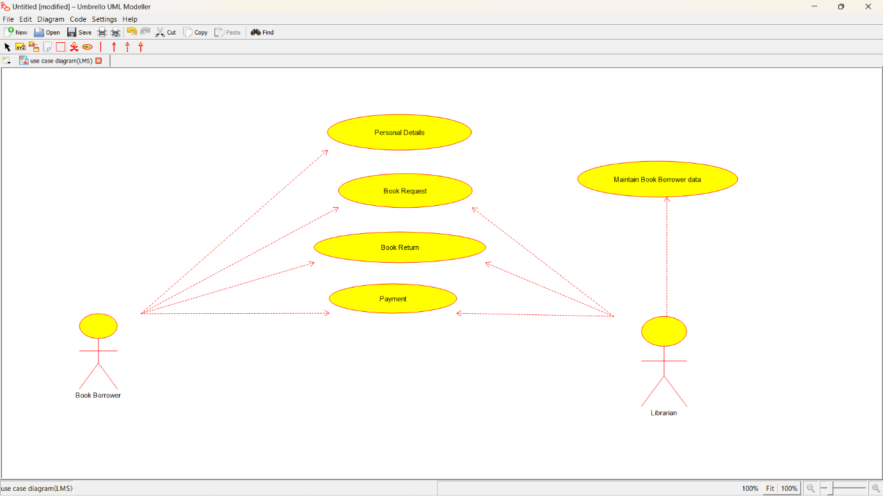

**CLASS DIAGRAM:**

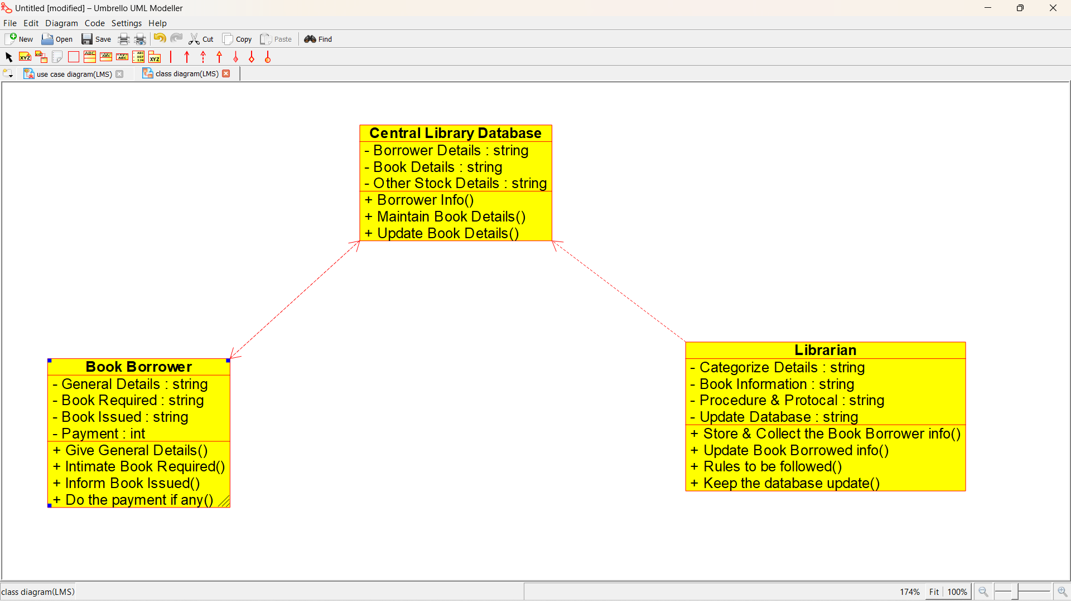

**ACTIVITY DIAGRAM:**

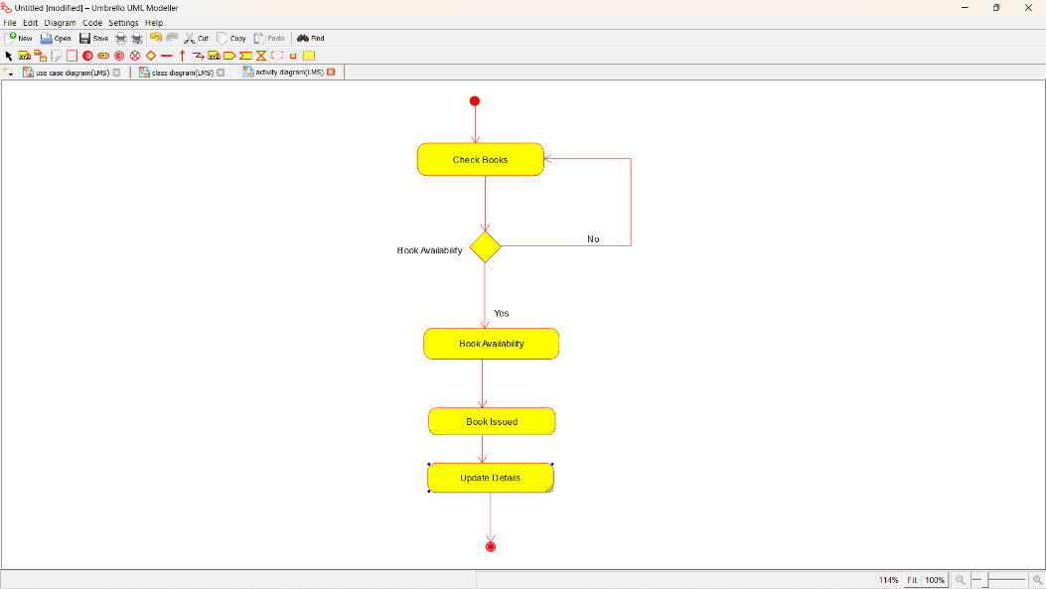

**SEQUENCE DIAGRAM:**

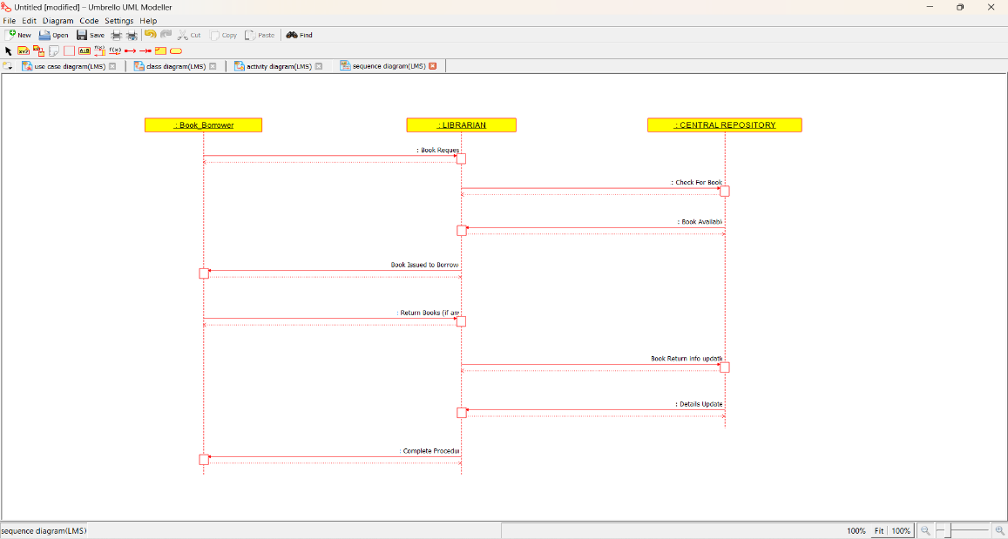

**COLLABORATION DIAGRAM:**

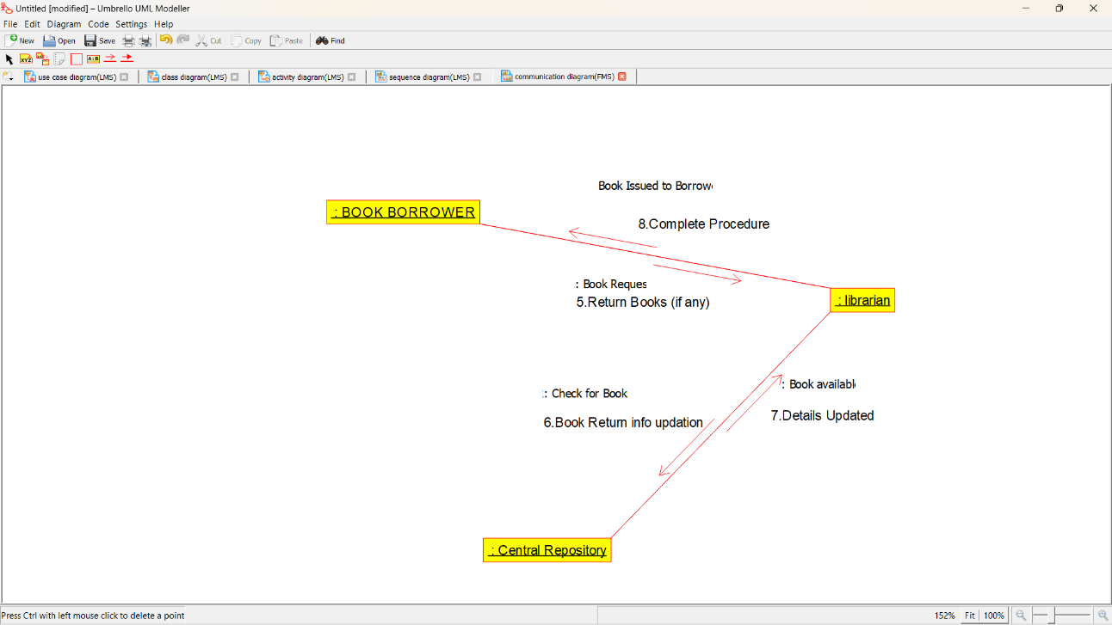

**STATE CHART DIAGRAM:**

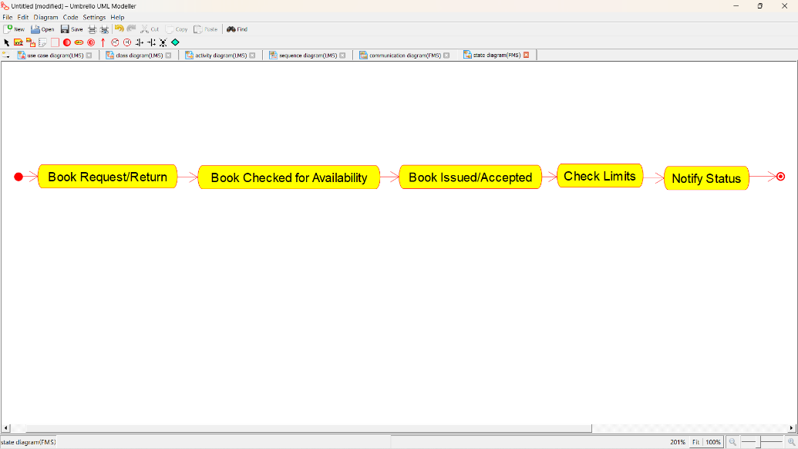

**COMPOMEMT DIAGRAM**:

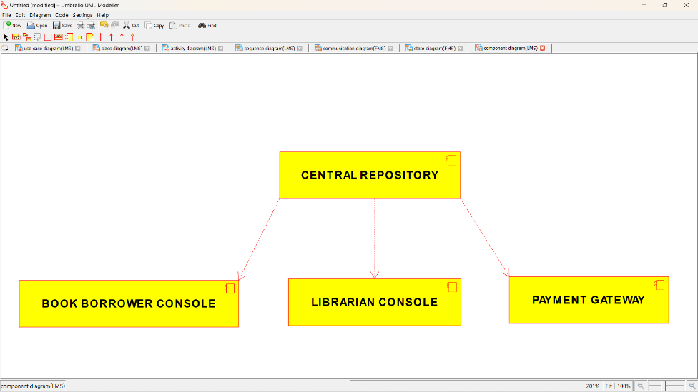

**DEPLOYMENT DIAGRAM:**

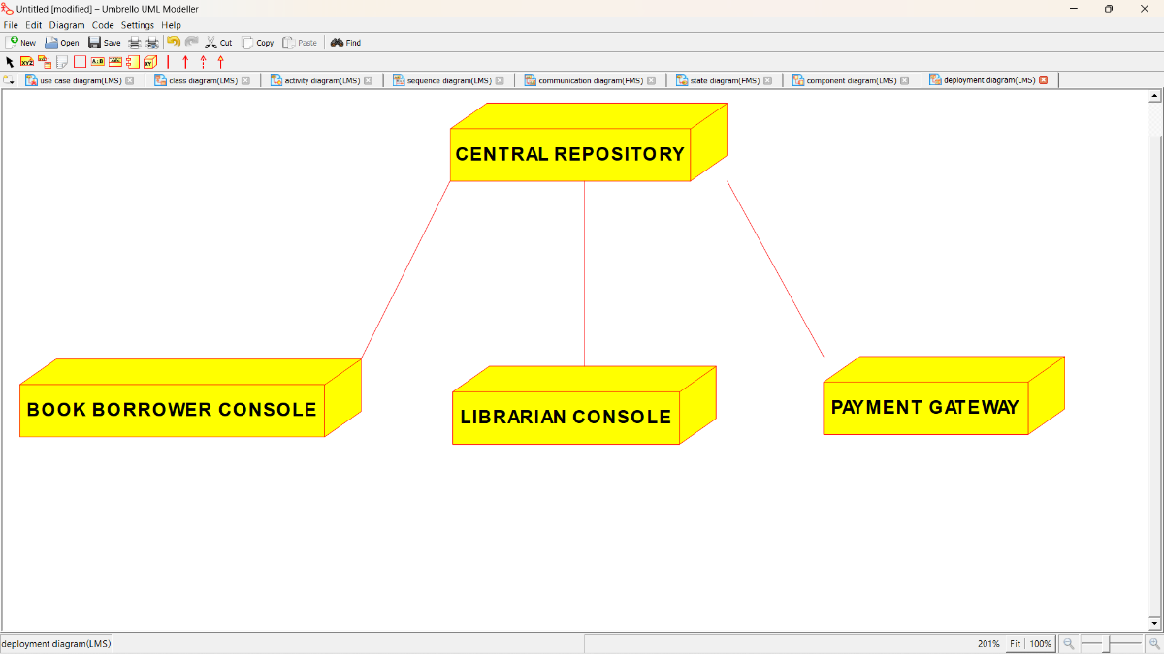

**PROGRAM CODING:**

/**

* Class Central_Library_Database

*/

public class Central_Library_Database {

//

// Fields

//

private String Borrower_Details;

private String Book_Details;

private String Other_Stock_Details;

//

// Constructors

//

public Central_Library_Database () { };

//

// Methods

//

//

// Accessor methods

//

/**

* Set the value of Borrower_Details

* @param newVar the new value of Borrower_Details

*/

private void setBorrower_Details (String newVar) {

Borrower_Details = newVar;

}

/**

* Get the value of Borrower_Details

* @return the value of Borrower_Details

*/

private String getBorrower_Details () {

return Borrower_Details;

}

/**

* Set the value of Book_Details

* @param newVar the new value of Book_Details

*/

private void setBook_Details (String newVar) {

Book_Details = newVar;

}

/**

* Get the value of Book_Details

* @return the value of Book_Details

*/

private String getBook_Details () {

return Book_Details;

}

/**

* Set the value of Other_Stock_Details

* @param newVar the new value of Other_Stock_Details

*/

private void setOther_Stock_Details (String newVar) {

Other_Stock_Details = newVar;

}

/**

* Get the value of Other_Stock_Details

* @return the value of Other_Stock_Details

*/

private String getOther_Stock_Details () {

return Other_Stock_Details;

}

//

// Other methods

//

/**

*/

public void Borrower_Info()

{

}

/**

*/

public void Maintain_Book_Details()

{

}

/**

*/

public void Update_Book_Details()

{

}

}

/**

* Class Book_Borrower

*/

public class Book_Borrower {

//

// Fields

//

private String General_Details;

private String Book_Required;

private String Book_Issued;

private int Payment;

//

// Constructors

//

public Book_Borrower () { };

//

// Methods

//

//

// Accessor methods

//

/**

* Set the value of General_Details

* @param newVar the new value of General_Details

*/

private void setGeneral_Details (String newVar) {

General_Details = newVar;

}

/**

* Get the value of General_Details

* @return the value of General_Details

*/

private String getGeneral_Details () {

return General_Details;

}

/**

* Set the value of Book_Required

* @param newVar the new value of Book_Required

*/

private void setBook_Required (String newVar) {

Book_Required = newVar;

}

/**

* Get the value of Book_Required

* @return the value of Book_Required

*/

private String getBook_Required () {

return Book_Required;

}

/**

* Set the value of Book_Issued

* @param newVar the new value of Book_Issued

*/

private void setBook_Issued (String newVar) {

Book_Issued = newVar;

}

/**

* Get the value of Book_Issued

* @return the value of Book_Issued

*/

private String getBook_Issued () {

return Book_Issued;

}

/**

* Set the value of Payment

* @param newVar the new value of Payment

*/

private void setPayment (int newVar) {

Payment = newVar;

}

/**

* Get the value of Payment

* @return the value of Payment

*/

private int getPayment () {

return Payment;

}

//

// Other methods

//

/**

*/

public void Give_General_Details()

{

}

/**

*/

public void Intimate_Book_Required()

{

}

/**

*/

public void Inform_Book_Issued()

{

}

/**

*/

public void Do_the_payment_if_any()

{

}

}

/**

* Class Librarian

*/

public class Librarian {

//

// Fields

//

private String Categorize_Details;

private String Book_Information;

private String Procedure_Protocal;

private String Update_Database;

//

// Constructors

//

public Librarian () { };

//

// Methods

//

//

// Accessor methods

//

/**

* Set the value of Categorize_Details

* @param newVar the new value of Categorize_Details

*/

private void setCategorize_Details (String newVar) {

Categorize_Details = newVar;

}

/**

* Get the value of Categorize_Details

* @return the value of Categorize_Details

*/

private String getCategorize_Details () {

return Categorize_Details;

}

/**

* Set the value of Book_Information

* @param newVar the new value of Book_Information

*/

private void setBook_Information (String newVar) {

Book_Information = newVar;

}

/**

* Get the value of Book_Information

* @return the value of Book_Information

*/

private String getBook_Information () {

return Book_Information;

}

/**

* Set the value of Procedure_Protocal

* @param newVar the new value of Procedure_Protocal

*/

private void setProcedure_Protocal (String newVar) {

Procedure_Protocal = newVar;

}

/**

* Get the value of Procedure_Protocal

* @return the value of Procedure_Protocal

*/

private String getProcedure_Protocal () {

return Procedure_Protocal;

}

/**

* Set the value of Update_Database

* @param newVar the new value of Update_Database

*/

private void setUpdate_Database (String newVar) {

Update_Database = newVar;

}

/**

* Get the value of Update_Database

* @return the value of Update_Database

*/

private String getUpdate_Database () {

return Update_Database;

}

//

// Other methods

//

/**

*/

public void Store_Collect_the_Book_Borrower_info()

{

}

/**

*/

public void Update_Book_Borrowed_info()

{

}

/**

*/

public void Rules_to_be_followed()

{

}

/**

*/

public void Keep_the_database_update()

{

}

}

**EX NO: 21 HOSPITAL MANAGEMENT SYSTEM**

**USECASE DIAGRAM:**

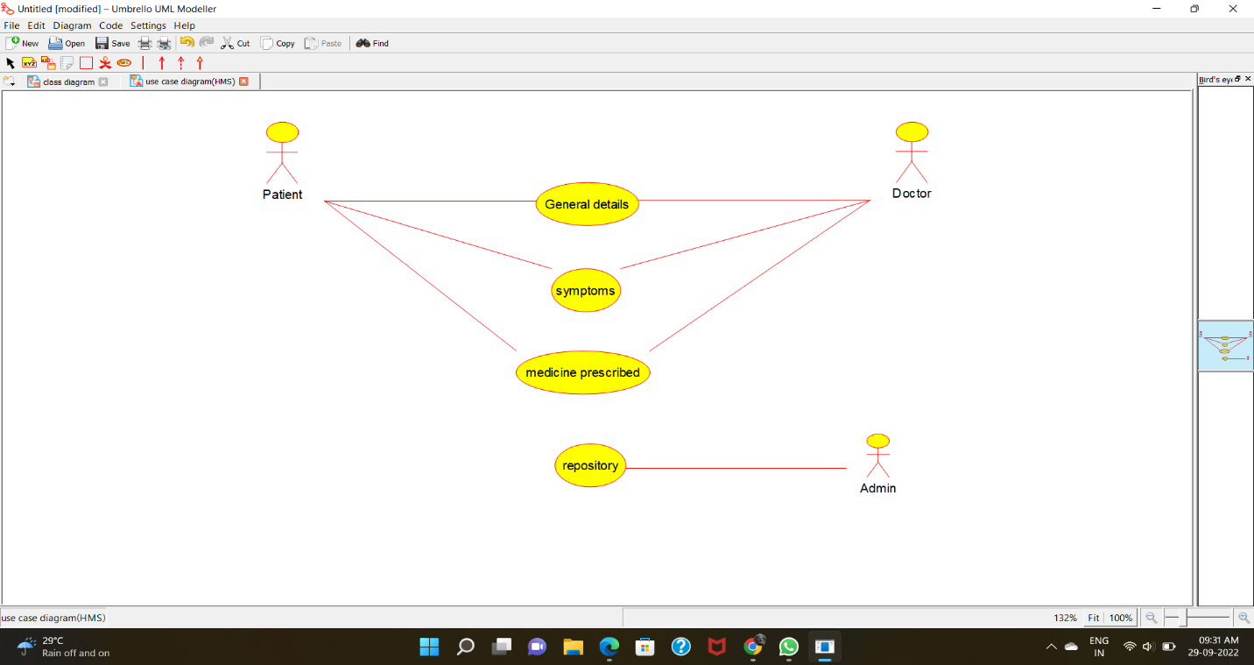

**CLASS DIAGRAM:**

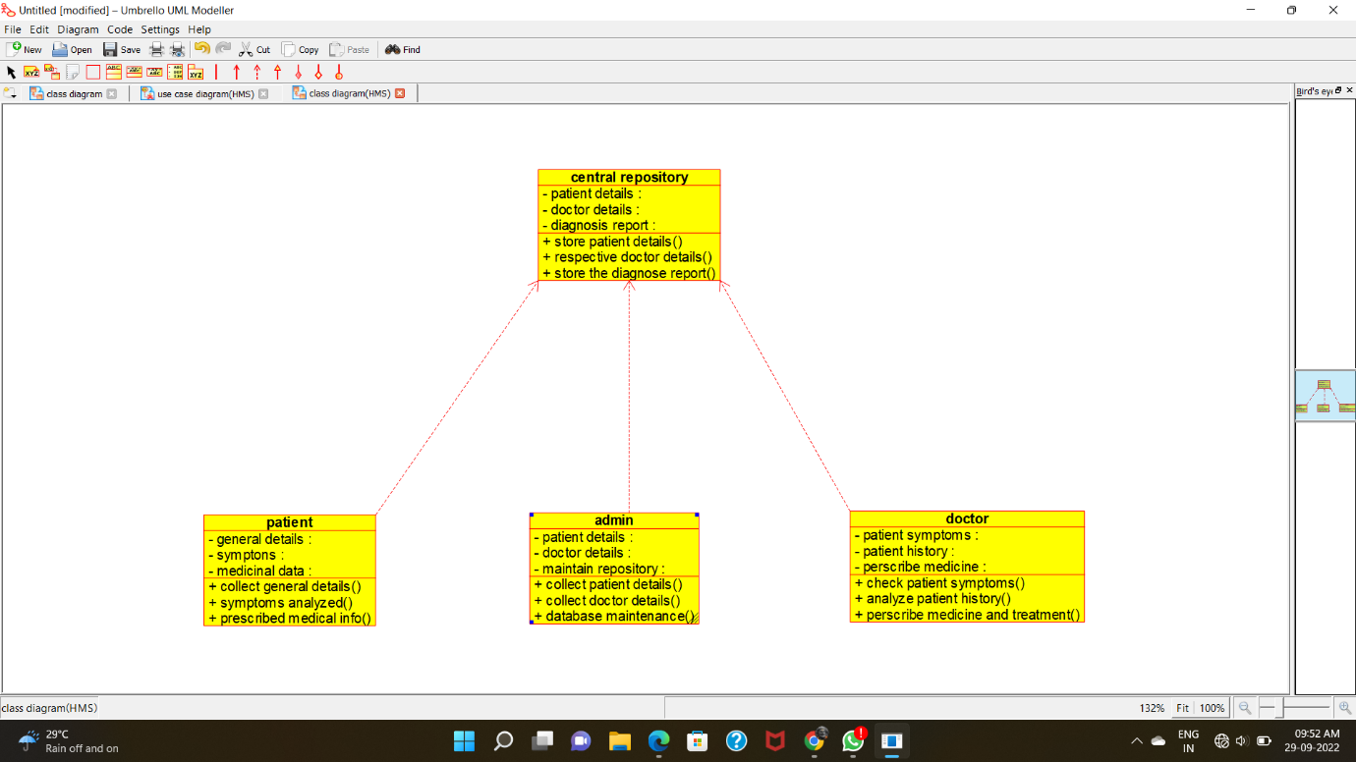

**ACTIVITY DIAGRAM:**

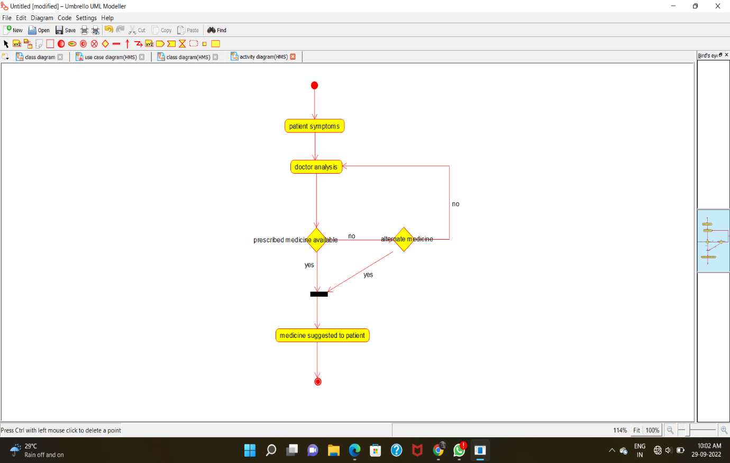

**SEQUENCE DIAGRAM:**

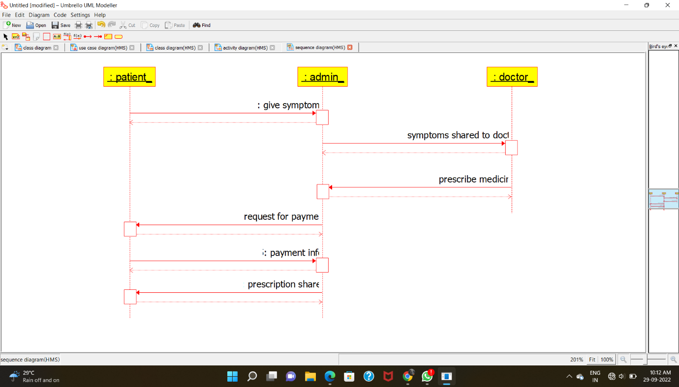

**COLLABRATION DIAGRAM:**

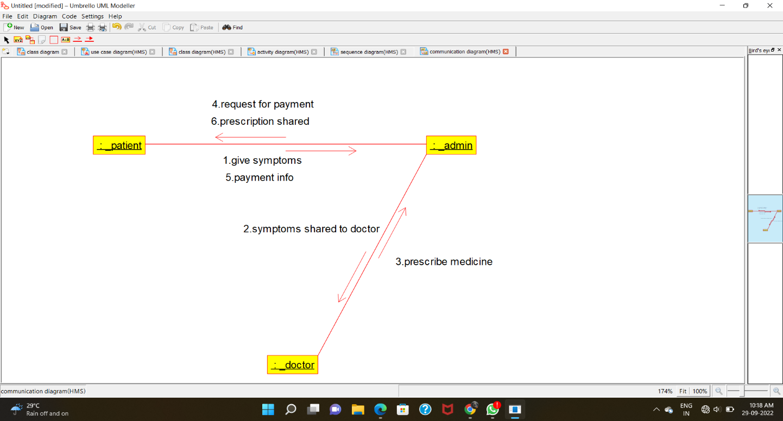

**STATE-CHART DIAGRAM:**

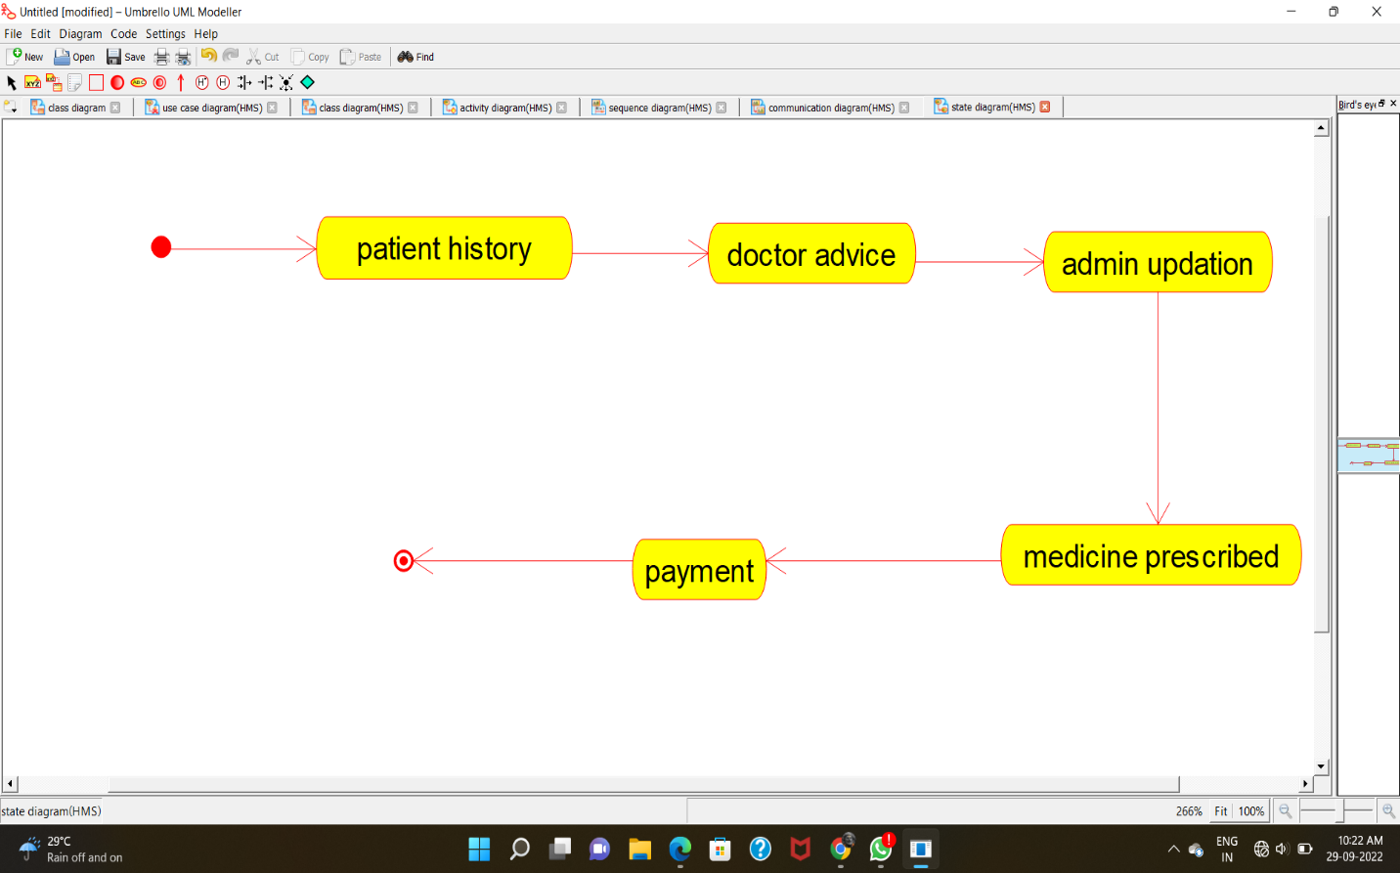

**COMPONENT DIAGRAM:**

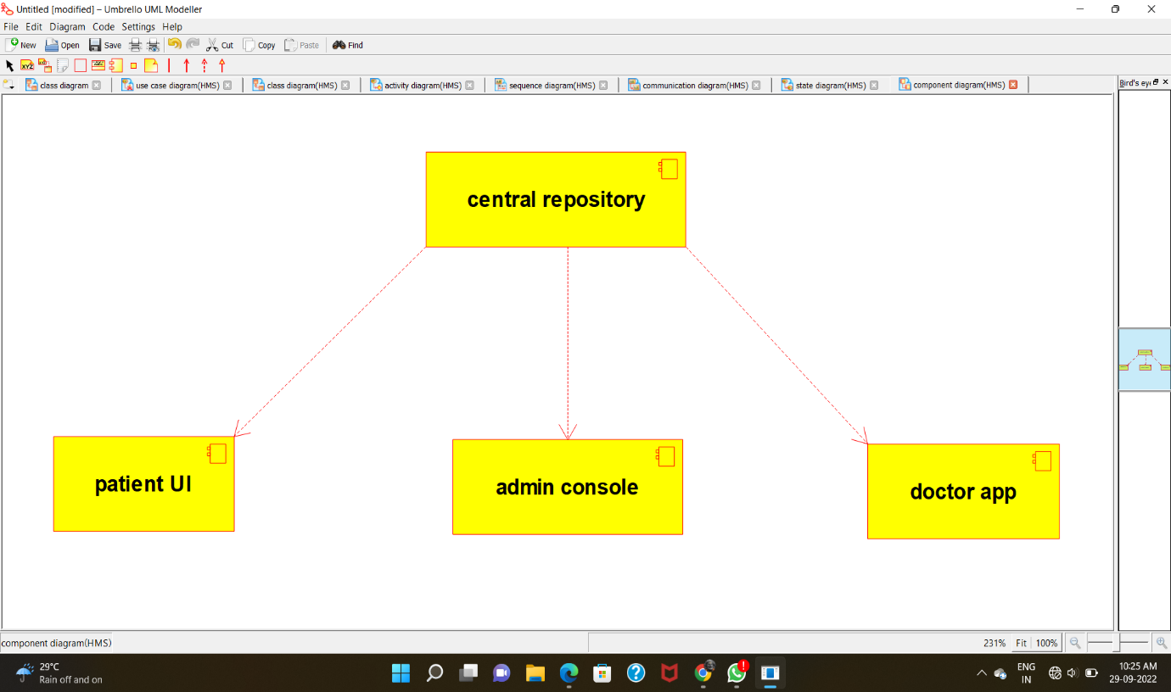

**DEPLOYMENT DIAGRAM:**

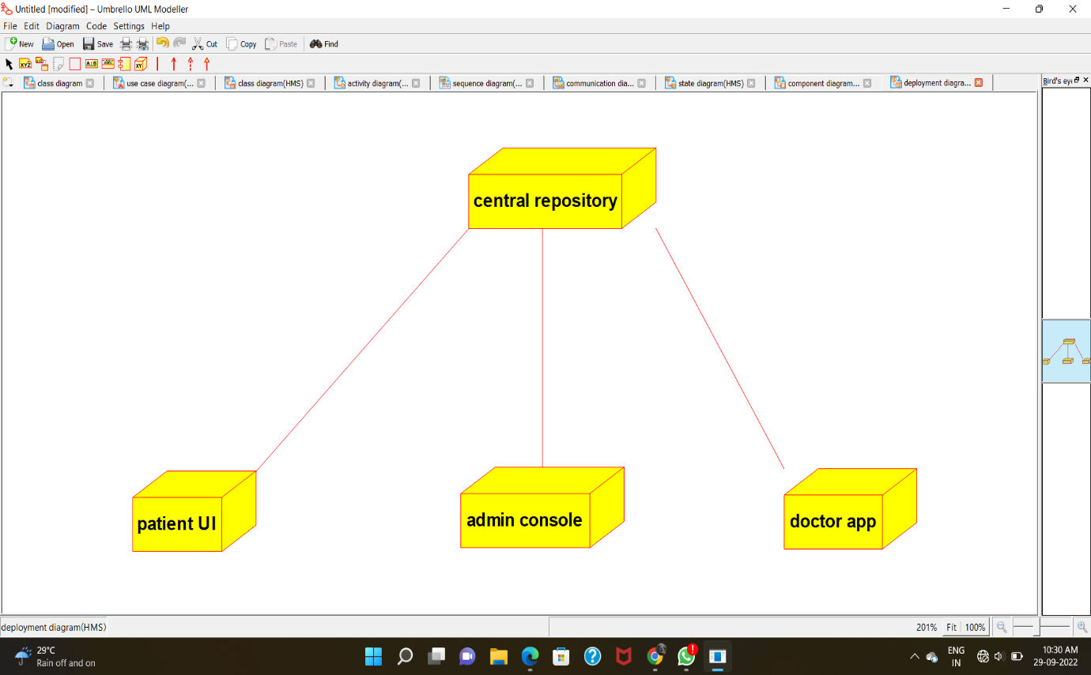

**PROGRAM CODE:**

CENTRAL REPOSITORY:

/**

* Class central_repository

*/

public class central_repository {

//

// Fields

//

private void patient_details;

private void doctor_details;

private void diagnosis_report;

//

// Constructors

//

public central_repository () { };

//

// Methods

//

//

// Accessor methods

//

/**

* Set the value of patient_details

* @param newVar the new value of patient_details

*/

private void setPatient_details (void newVar) {

patient_details = newVar;

}

/**

* Get the value of patient_details

* @return the value of patient_details

*/

private void getPatient_details () {

return patient_details;

}

/**

* Set the value of doctor_details

* @param newVar the new value of doctor_details

*/

private void setDoctor_details (void newVar) {

doctor_details = newVar;

}

/**

* Get the value of doctor_details

* @return the value of doctor_details

*/

private void getDoctor_details () {

return doctor_details;

}

/**

* Set the value of diagnosis_report

* @param newVar the new value of diagnosis_report

*/

private void setDiagnosis_report (void newVar) {

diagnosis_report = newVar;

}

/**

* Get the value of diagnosis_report

* @return the value of diagnosis_report

*/

private void getDiagnosis_report () {

return diagnosis_report;

}

//

// Other methods

//

/**

*/

public void store_patient_details()

{

}

/**

*/

public void respective_doctor_details()

{

}

/**

*/

public void store_the_diagnose_report()

{

}

}

**PATIENT:**

/**

* Class patient

*/

public class patient {

//

// Fields

//

private void general_details;

private void symptons;

private void medicinal_data;

//

// Constructors

//

public patient () { };

//

// Methods

//

//

// Accessor methods

//

/**

* Set the value of general_details

* @param newVar the new value of general_details

*/

private void setGeneral_details (void newVar) {

general_details = newVar;

}

/**

* Get the value of general_details

* @return the value of general_details

*/

private void getGeneral_details () {

return general_details;

}

/**

* Set the value of symptons

* @param newVar the new value of symptons

*/

private void setSymptons (void newVar) {

symptons = newVar;

}

/**

* Get the value of symptons

* @return the value of symptons

*/

private void getSymptons () {

return symptons;

}

/**

* Set the value of medicinal_data

* @param newVar the new value of medicinal_data

*/

private void setMedicinal_data (void newVar) {

medicinal_data = newVar;

}

/**

* Get the value of medicinal_data

* @return the value of medicinal_data

*/

private void getMedicinal_data () {

return medicinal_data;

}

//

// Other methods

//

/**

*/

public void collect_general_details()

{

}

/**

*/

public void symptoms_analyzed()

{

}

/**

*/

public void prescribed_medical_info()

{

}

}

**ADMIN:**

/**

* Class admin

*/

public class admin {

//

// Fields

//

private void patient_details;

private void doctor_details;

private void maintain_repository;

//

// Constructors

//

public admin () { };

//

// Methods

//

//

// Accessor methods

//

/**

* Set the value of patient_details

* @param newVar the new value of patient_details

*/

private void setPatient_details (void newVar) {

patient_details = newVar;

}

/**

* Get the value of patient_details

* @return the value of patient_details

*/

private void getPatient_details () {

return patient_details;

}

/**

* Set the value of doctor_details

* @param newVar the new value of doctor_details

*/

private void setDoctor_details (void newVar) {

doctor_details = newVar;

}

/**

* Get the value of doctor_details

* @return the value of doctor_details

*/

private void getDoctor_details () {

return doctor_details;

}

/**

* Set the value of maintain_repository

* @param newVar the new value of maintain_repository

*/

private void setMaintain_repository (void newVar) {

maintain_repository = newVar;

}

/**

* Get the value of maintain_repository

* @return the value of maintain_repository

*/

private void getMaintain_repository () {

return maintain_repository;

}

//

// Other methods

//

/**

*/

public void collect_patient_details()

{

}

/**

*/

public void collect_doctor_details()

{

}

/**

*/

public void database_maintenance()

{

}

}

DOCTOR:

/**

* Class doctor

*/

public class doctor {

//

// Fields

//

private void patient_symptoms;

private void patient_history;

private void perscribe_medicine;

//

// Constructors

//

public doctor () { };

//

// Methods

//

//

// Accessor methods

//

/**

* Set the value of patient_symptoms

* @param newVar the new value of patient_symptoms

*/

private void setPatient_symptoms (void newVar) {

patient_symptoms = newVar;

}

/**

* Get the value of patient_symptoms

* @return the value of patient_symptoms

*/

private void getPatient_symptoms () {

return patient_symptoms;

}

/**

* Set the value of patient_history

* @param newVar the new value of patient_history

*/

private void setPatient_history (void newVar) {

patient_history = newVar;

}

/**

* Get the value of patient_history

* @return the value of patient_history

*/

private void getPatient_history () {

return patient_history;

}

/**

* Set the value of perscribe_medicine

* @param newVar the new value of perscribe_medicine

*/

private void setPerscribe_medicine (void newVar) {

perscribe_medicine = newVar;

}

/**

* Get the value of perscribe_medicine

* @return the value of perscribe_medicine

*/

private void getPerscribe_medicine () {

return perscribe_medicine;

}

//

// Other methods

//

/**

*/

public void check_patient_symptoms()

{

}

/**

*/

public void analyze_patient_history()

{

}

/**

*/

public void perscribe_medicine_and_treatment()

{

}

}

**EX NO :23 ONLINE SHOPPING SYSTEM**

**USE CASE DIAGRAM:**

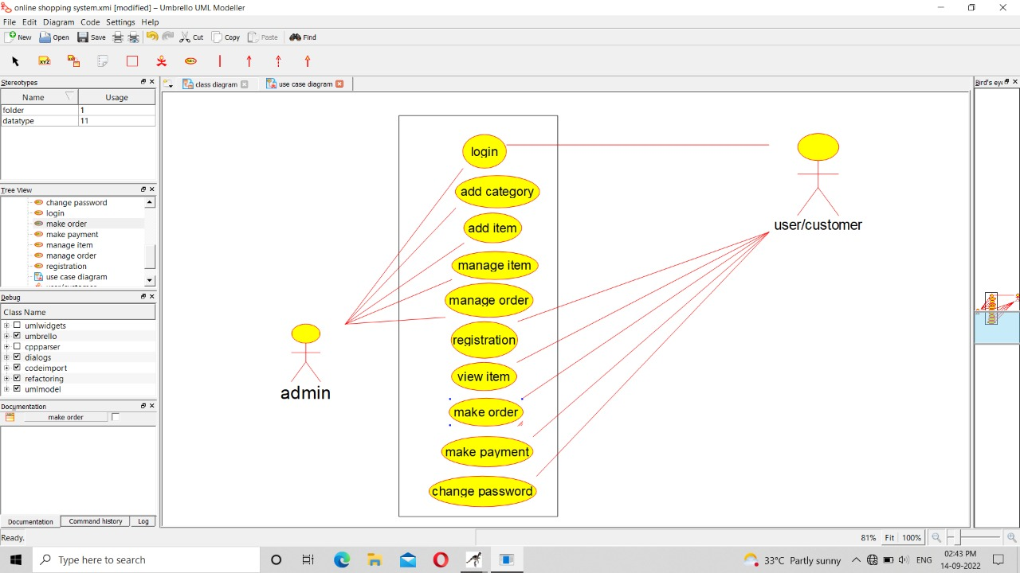

**CLASS DIAGRAM:**

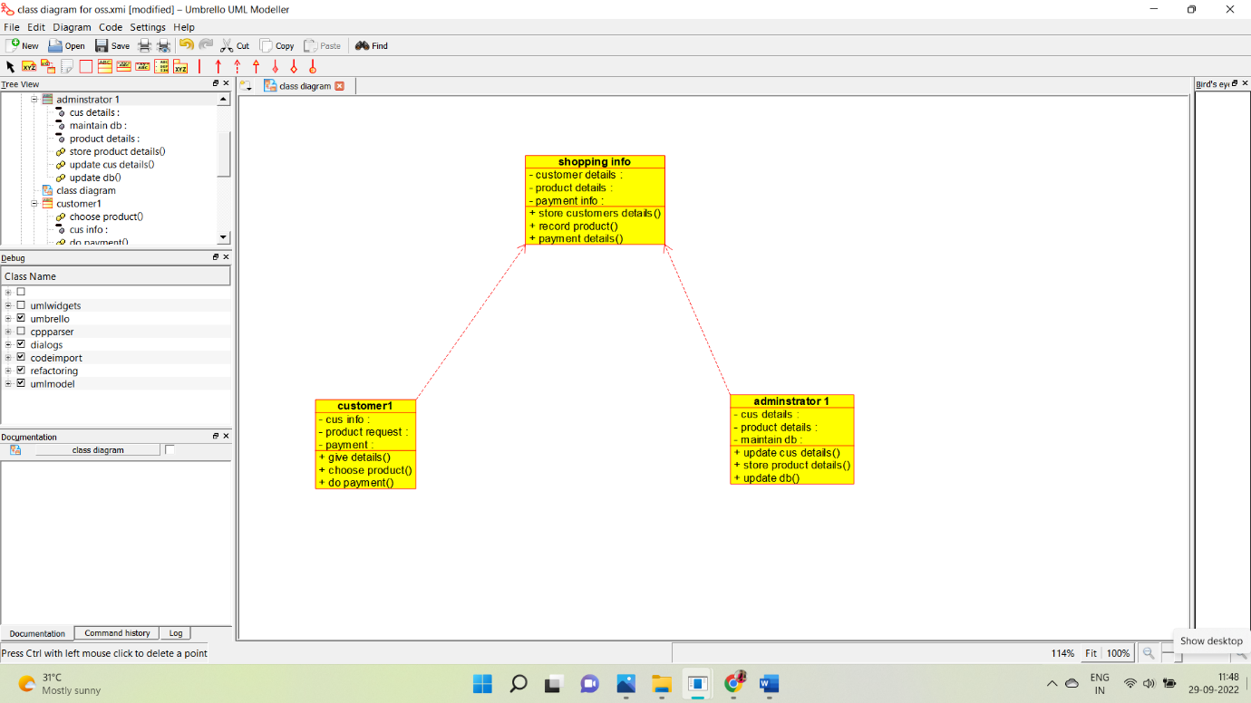

**ACTIVITY DIAGRAM:**

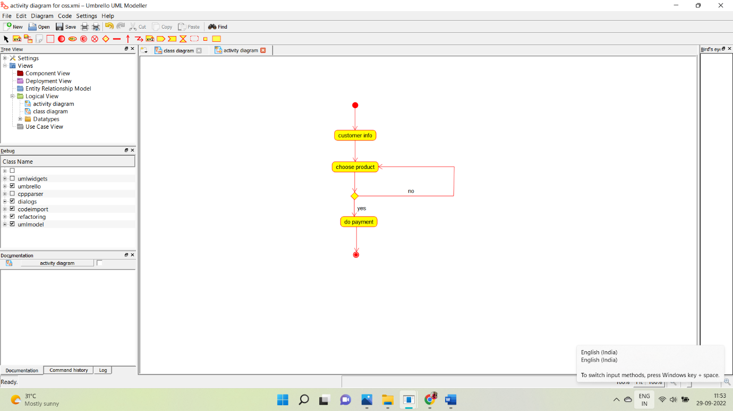

**SEQUENCE DIAGRAM:**

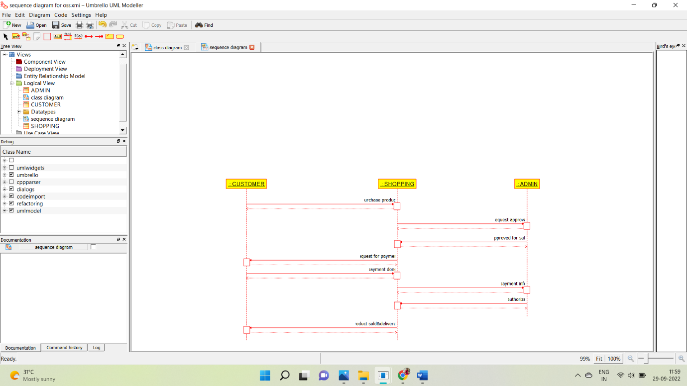

**COLLABORATION DIAGRAM:**

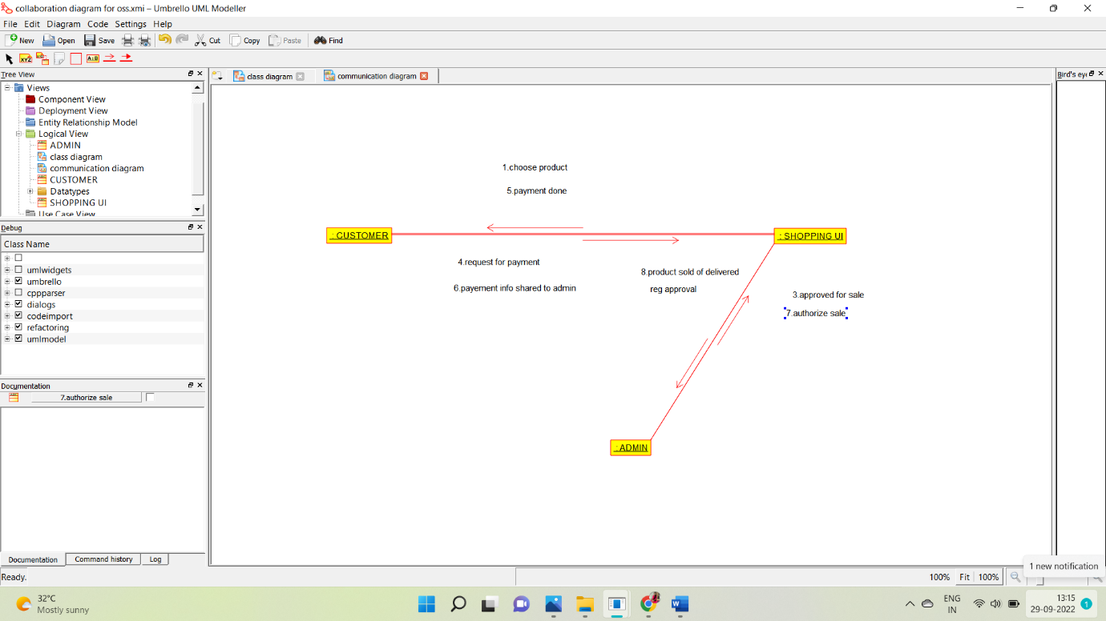

**STATE CHART DIAGRAM:**

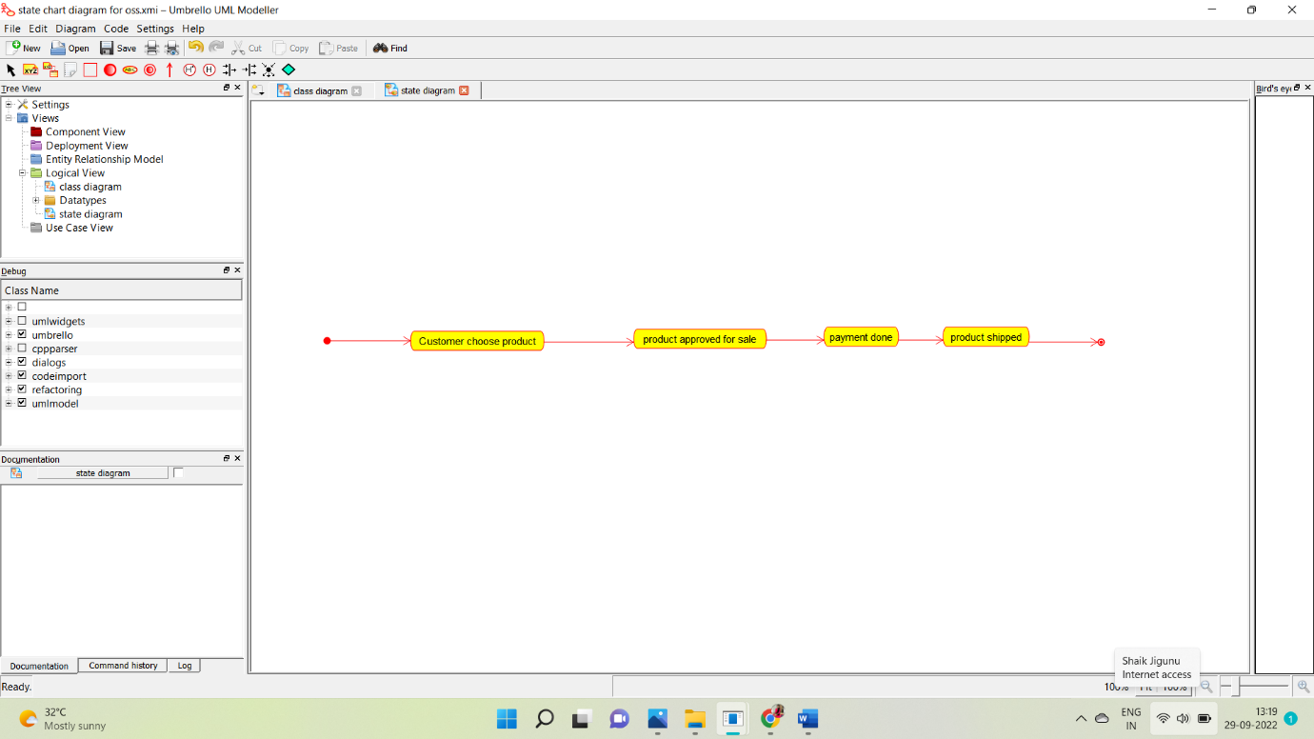

**COMPONENT DIAGRAM:**

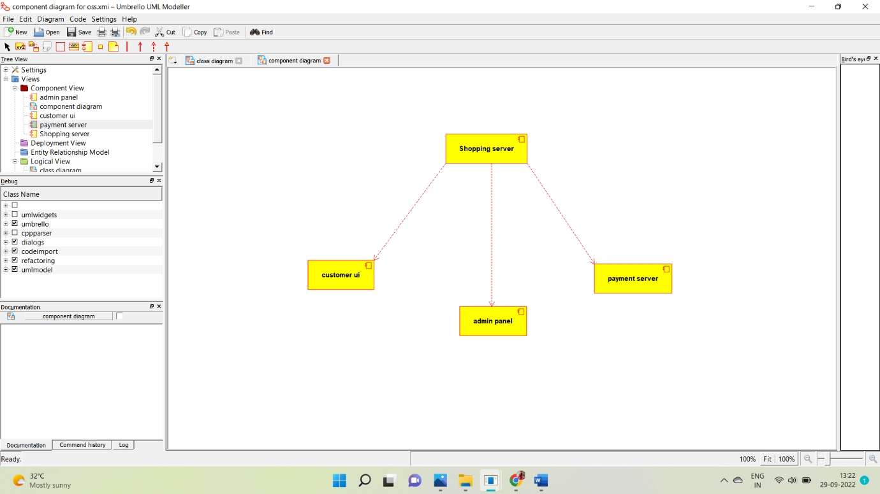

**DEPLOYMENT DIAGRAM:**

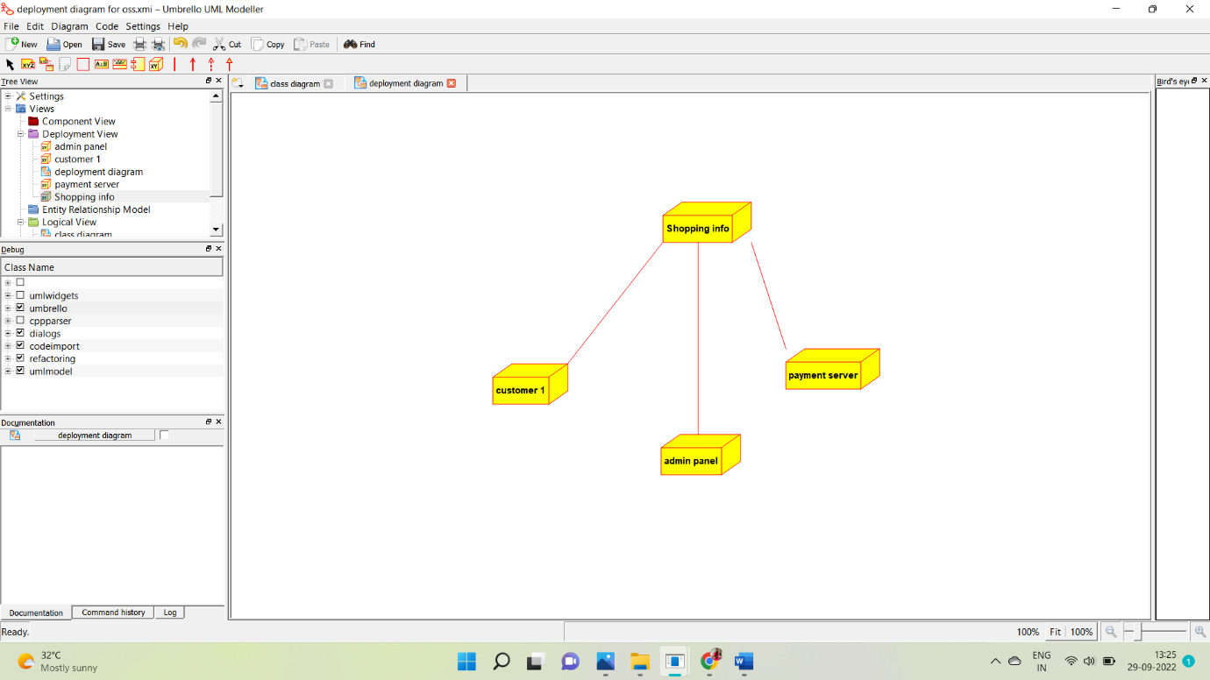

**PROGRAM:**

**/\*\***

**\* Class shopping_info**

**\*/**

**public class shopping_info {**

**//**

**// Fields**

**//**

**private void customer_details;**

**private void product_details;**

**private void payment_info;**

**//**

**// Constructors**

**//**

**public shopping_info () { };**

**//**

**// Methods**

**//**

**//**

**// Accessor methods**

**//**

**/\*\***

**\* Set the value of customer_details**

**\* @param newVar the new value of customer_details**

**\*/**

**private void setCustomer_details (void newVar) {**

**customer_details = newVar;**

**}**

**/\*\***

**\* Get the value of customer_details**

**\* @return the value of customer_details**

**\*/**

**private void getCustomer_details () {**

**return customer_details;**

**}**

**/\*\***

**\* Set the value of product_details**

**\* @param newVar the new value of product_details**

**\*/**

**private void setProduct_details (void newVar) {**

**product_details = newVar;**

**}**

**/\*\***

**\* Get the value of product_details**

**\* @return the value of product_details**

**\*/**

**private void getProduct_details () {**

**return product_details;**

**}**

**/\*\***

**\* Set the value of payment_info**

**\* @param newVar the new value of payment_info**

**\*/**

**private void setPayment_info (void newVar) {**

**payment_info = newVar;**

**}**

**/\*\***

**\* Get the value of payment_info**

**\* @return the value of payment_info**

**\*/**

**private void getPayment_info () {**

**return payment_info;**

**}**

**//**

**// Other methods**

**//**

**/\*\***

**\*/**

**public void store_customers_details()**

**{**

**}**

**/\*\***

**\*/**

**public void record_product()**

**{**

**}**

**/\*\***

**\*/**

**public void payment_details()**

**{**

**}**

**}**

**/\*\***

**\* Class customer1**

**\*/**

**public class customer1 {**

**//**

**// Fields**

**//**

**private void cus_info;**

**private void product_request;**

**private void payment;**

**//**

**// Constructors**

**//**

**public customer1 () { };**

**//**

**// Methods**

**//**

**//**

**// Accessor methods**

**//**

**/\*\***

**\* Set the value of cus_info**

**\* @param newVar the new value of cus_info**

**\*/**

**private void setCus_info (void newVar) {**

**cus_info = newVar;**

**}**

**/\*\***

**\* Get the value of cus_info**

**\* @return the value of cus_info**

**\*/**

**private void getCus_info () {**

**return cus_info;**

**}**

**/\*\***

**\* Set the value of product_request**

**\* @param newVar the new value of product_request**

**\*/**

**private void setProduct_request (void newVar) {**

**product_request = newVar;**

**}**

**/\*\***

**\* Get the value of product_request**

**\* @return the value of product_request**

**\*/**

**private void getProduct_request () {**

**return product_request;**

**}**

**/\*\***

**\* Set the value of payment**

**\* @param newVar the new value of payment**

**\*/**

**private void setPayment (void newVar) {**

**payment = newVar;**

**}**

**/\*\***

**\* Get the value of payment**

**\* @return the value of payment**

**\*/**

**private void getPayment () {**

**return payment;**

**}**

**//**

**// Other methods**

**//**

**/\*\***

**\*/**

**public void give_details()**

**{**

**}**

**/\*\***

**\*/**

**public void choose_product()**

**{**

**}**

**/\*\***

**\*/**

**public void do_payment()**

**{**

**}**

**}**

**/\*\***

**\* Class adminstrator_1**

**\*/**

**public class adminstrator_1 {**

**//**

**// Fields**

**//**

**private void cus_details;**

**private void product_details;**

**private void maintain_db;**

**//**

**// Constructors**

**//**

**public adminstrator_1 () { };**

**//**

**// Methods**

**//**

**//**

**// Accessor methods**

**//**

**/\*\***

**\* Set the value of cus_details**

**\* @param newVar the new value of cus_details**

**\*/**

**private void setCus_details (void newVar) {**

**cus_details = newVar;**

**}**

**/\*\***

**\* Get the value of cus_details**

**\* @return the value of cus_details**

**\*/**

**private void getCus_details () {**

**return cus_details;**

**}**

**/\*\***

**\* Set the value of product_details**

**\* @param newVar the new value of product_details**

**\*/**

**private void setProduct_details (void newVar) {**

**product_details = newVar;**

**}**

**/\*\***

**\* Get the value of product_details**

**\* @return the value of product_details**

**\*/**

**private void getProduct_details () {**

**return product_details;**

**}**

**/\*\***

**\* Set the value of maintain_db**

**\* @param newVar the new value of maintain_db**

**\*/**

**private void setMaintain_db (void newVar) {**

**maintain_db = newVar;**

**}**

**/\*\***

**\* Get the value of maintain_db**

**\* @return the value of maintain_db**

**\*/**

**private void getMaintain_db () {**

**return maintain_db;**

**}**

**//**

**// Other methods**

**//**

**/\*\***

**\*/**

**public void update_cus_details()**

**{**

**}**

**/\*\***

**\*/**

**public void store_product_details()**

**{**

**}**

**/\*\***

**\*/**

**public void update_db()**

**{**

**}**

**}**

**EX NO:24 ONLINE STOCK MONITORING SYSTEM**

**USE CASE DIAGRAM:**

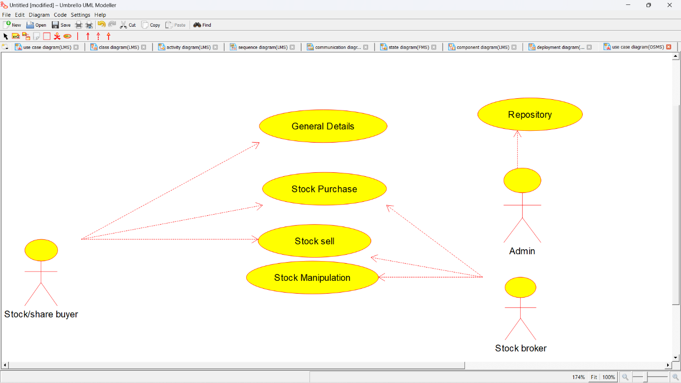

**CLASS DIAGRAM:**

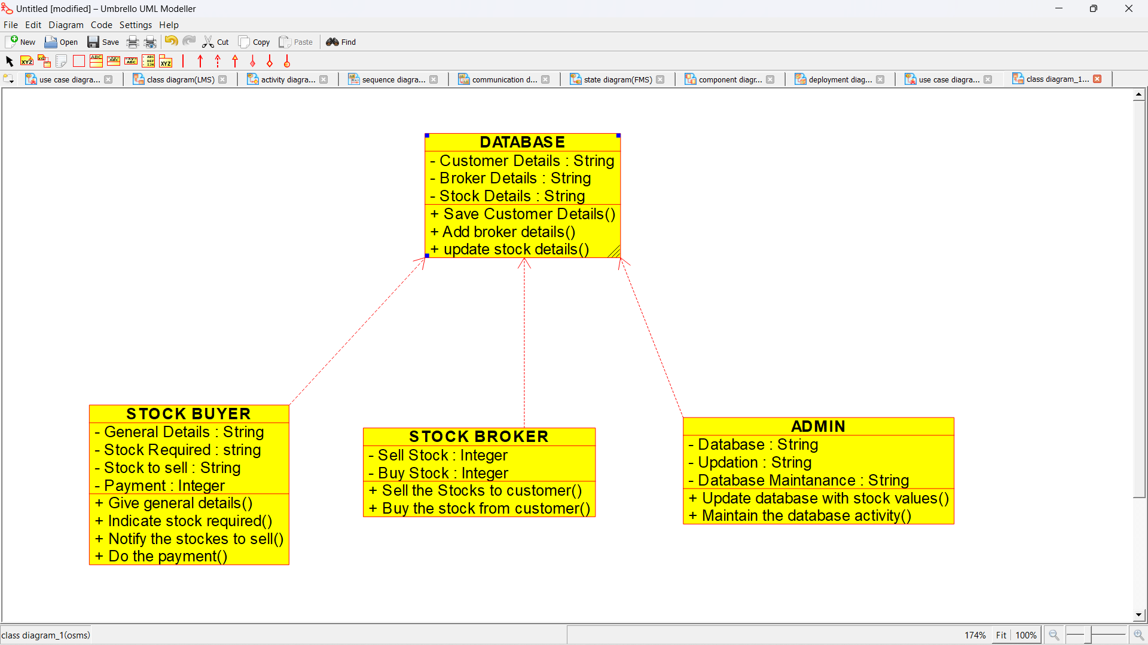

**ACTIVITY DIAGRAM:**

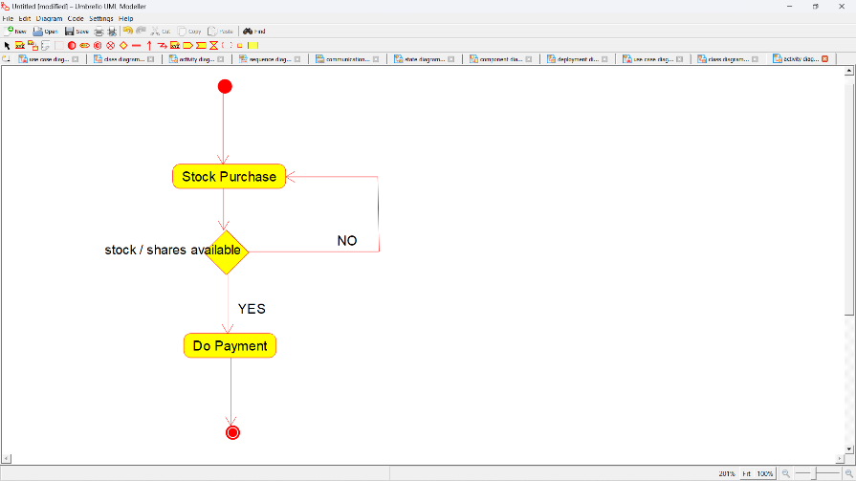

**SEQUENCE DIAGRAM:**

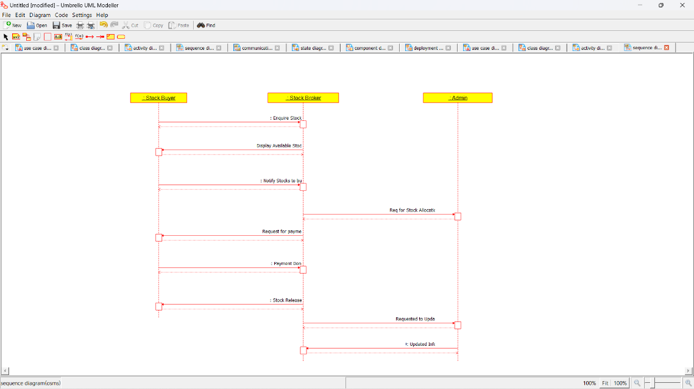

**COLLABORATION DIAGRAM:**

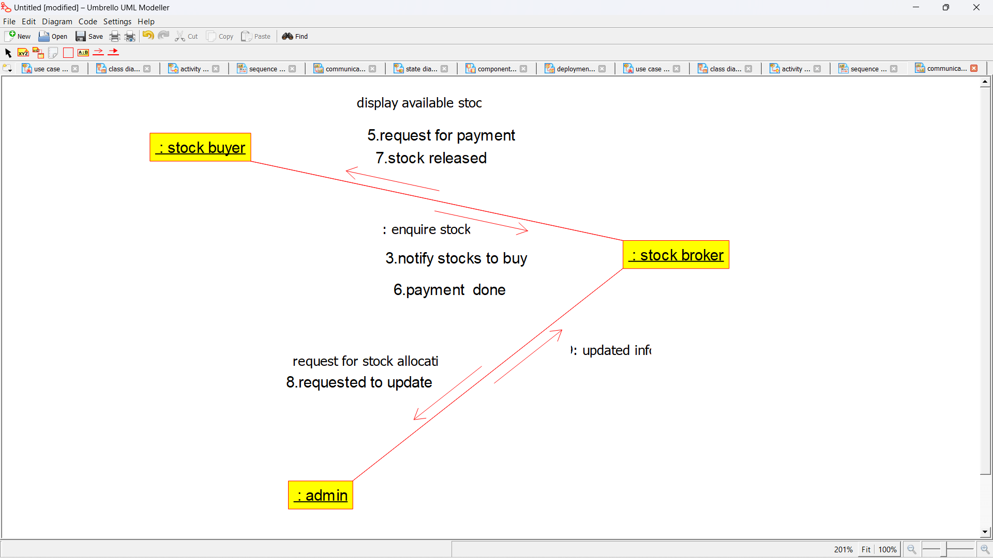

**STATE CHART DIAGRAM:**

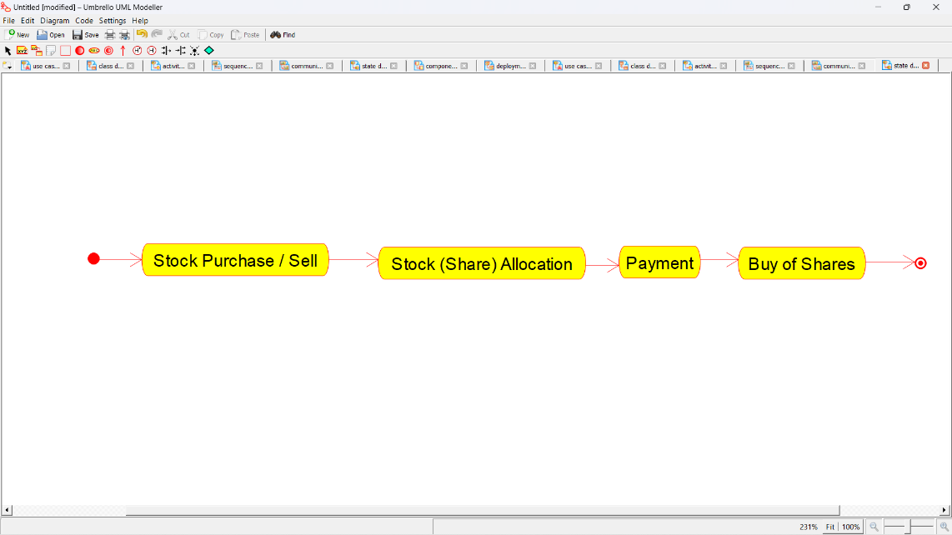

**COMPONENT DIAGRAM:**

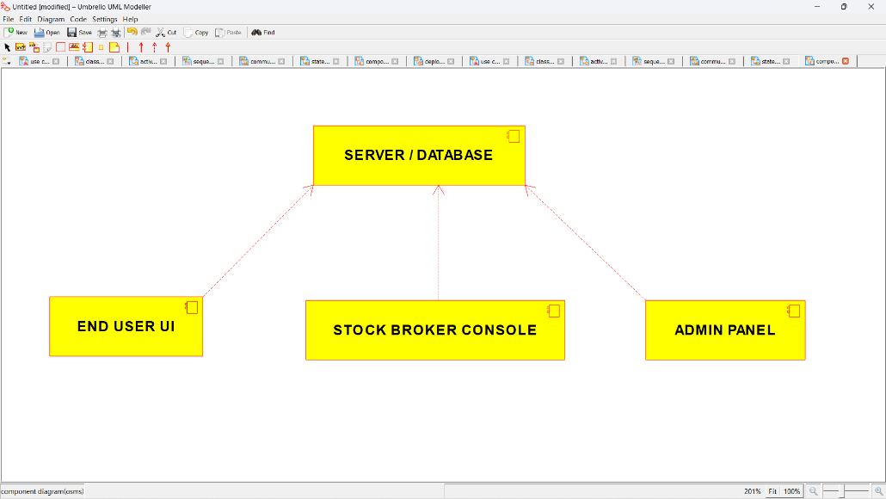

**DEPLOYMENT DIAGRAM:**

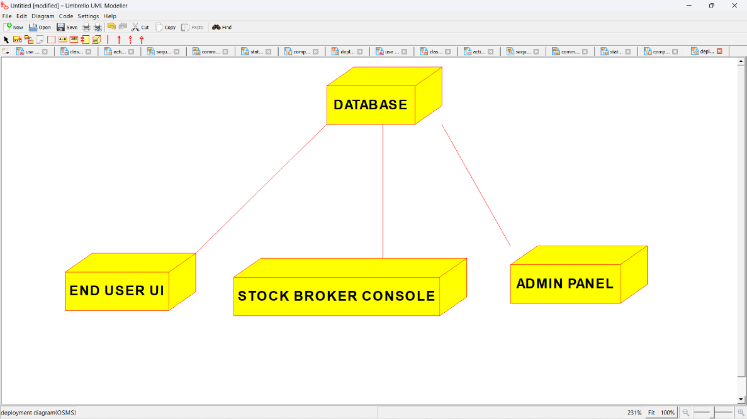

**PROGRAM COD ING**

/**

* Class ADMIN

*/

public class ADMIN {

//

// Fields

//

private String Database;

private String Updation;

private String Database_Maintanance;

//

// Constructors

//

public ADMIN () { };

//

// Methods

//

//

// Accessor methods

//

/**

* Set the value of Database

* @param newVar the new value of Database

*/

private void setDatabase (String newVar) {

Database = newVar;

}

/**

* Get the value of Database

* @return the value of Database

*/

private String getDatabase () {

return Database;

}

/**

* Set the value of Updation

* @param newVar the new value of Updation

*/

private void setUpdation (String newVar) {

Updation = newVar;

}

/**

* Get the value of Updation

* @return the value of Updation

*/

private String getUpdation () {

return Updation;

}

/**

* Set the value of Database_Maintanance

* @param newVar the new value of Database_Maintanance

*/

private void setDatabase_Maintanance (String newVar) {

Database_Maintanance = newVar;

}

/**

* Get the value of Database_Maintanance

* @return the value of Database_Maintanance

*/

private String getDatabase_Maintanance () {

return Database_Maintanance;

}

//

// Other methods

//

/**

*/

public void Update_database_with_stock_values()

{

}

/**

*/

public void Maintain_the_database_activity()

{

}

}

/**

* Class DATABASE

*/

public class DATABASE {

//

// Fields

//

private String Customer_Details;

private String Broker_Details;

private String Stock_Details;

//

// Constructors

//

public DATABASE () { };

//

// Methods

//

//

// Accessor methods

//

/**

* Set the value of Customer_Details

* @param newVar the new value of Customer_Details

*/

private void setCustomer_Details (String newVar) {

Customer_Details = newVar;

}

/**

* Get the value of Customer_Details

* @return the value of Customer_Details

*/

private String getCustomer_Details () {

return Customer_Details;

}

/**

* Set the value of Broker_Details

* @param newVar the new value of Broker_Details

*/

private void setBroker_Details (String newVar) {

Broker_Details = newVar;

}

/**

* Get the value of Broker_Details

* @return the value of Broker_Details

*/

private String getBroker_Details () {

return Broker_Details;

}

/**

* Set the value of Stock_Details

* @param newVar the new value of Stock_Details

*/

private void setStock_Details (String newVar) {

Stock_Details = newVar;

}

/**

* Get the value of Stock_Details

* @return the value of Stock_Details

*/

private String getStock_Details () {

return Stock_Details;

}

//

// Other methods

//

/**

*/

public void Save_Customer_Details()

{

}

/**

*/

public void Add_broker_details()

{

}

/**

*/

public void update_stock_details()

{

}

}

/**

* Class STOCK_BROKER

*/

public class STOCK_BROKER {

//

// Fields

//

private Integer Sell_Stock;

private Integer Buy_Stock;

//

// Constructors

//

public STOCK_BROKER () { };

//

// Methods

//

//

// Accessor methods

//

/**

* Set the value of Sell_Stock

* @param newVar the new value of Sell_Stock

*/

private void setSell_Stock (Integer newVar) {

Sell_Stock = newVar;

}

/**

* Get the value of Sell_Stock

* @return the value of Sell_Stock

*/

private Integer getSell_Stock () {

return Sell_Stock;

}

/**

* Set the value of Buy_Stock

* @param newVar the new value of Buy_Stock

*/

private void setBuy_Stock (Integer newVar) {

Buy_Stock = newVar;

}

/**

* Get the value of Buy_Stock

* @return the value of Buy_Stock

*/

private Integer getBuy_Stock () {

return Buy_Stock;

}

//

// Other methods

//

/**

*/

public void Sell_the_Stocks_to_customer()

{

}

/**

*/

public void Buy_the_stock_from_customer()

{

}

}

/**

* Class STOCK_BUYER

*/

public class STOCK_BUYER {

//

// Fields

//

private String General_Details;

private String Stock_Required;

private String Stock_to_sell;

private Integer Payment;

//

// Constructors

//

public STOCK_BUYER () { };

//

// Methods

//

//

// Accessor methods

//

/**

* Set the value of General_Details

* @param newVar the new value of General_Details

*/

private void setGeneral_Details (String newVar) {

General_Details = newVar;

}

/**

* Get the value of General_Details

* @return the value of General_Details

*/

private String getGeneral_Details () {

return General_Details;

}

/**

* Set the value of Stock_Required

* @param newVar the new value of Stock_Required

*/

private void setStock_Required (String newVar) {

Stock_Required = newVar;

}

/**

* Get the value of Stock_Required

* @return the value of Stock_Required

*/

private String getStock_Required () {

return Stock_Required;

}

/**

* Set the value of Stock_to_sell

* @param newVar the new value of Stock_to_sell

*/

private void setStock_to_sell (String newVar) {

Stock_to_sell = newVar;

}

/**

* Get the value of Stock_to_sell

* @return the value of Stock_to_sell

*/

private String getStock_to_sell () {

return Stock_to_sell;

}

/**

* Set the value of Payment

* @param newVar the new value of Payment

*/

private void setPayment (Integer newVar) {

Payment = newVar;

}

/**

* Get the value of Payment

* @return the value of Payment

*/

private Integer getPayment () {

return Payment;

}

//

// Other methods

//

/**

*/

public void Give_general_details()

{

}

/**

*/

public void Indicate_stock_required()

{

}

/**

*/

public void Notify_the_stockes_to_sell()

{

}

/**

*/

public void Do_the_payment()

{

}

}

**EX NO 25: ONLINE VOTING SYSTEM**

**USECASE DIAGRAM:**

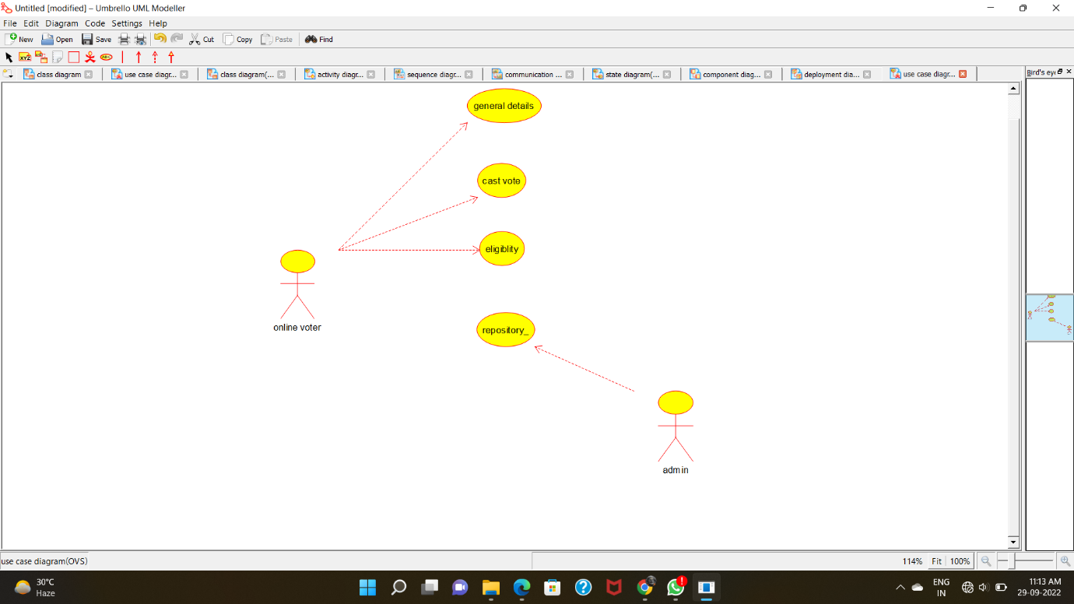

**CLASS DIAGRAM:**

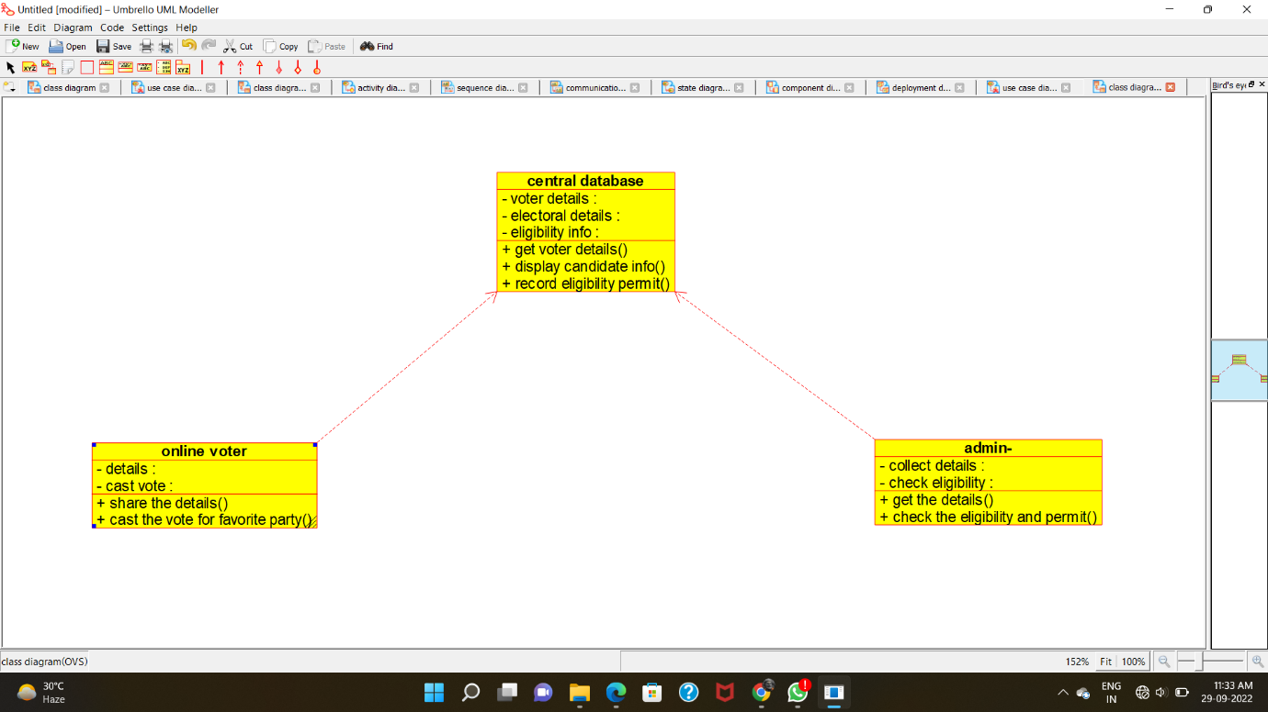

**ACTIVITY DIAGRAM:**

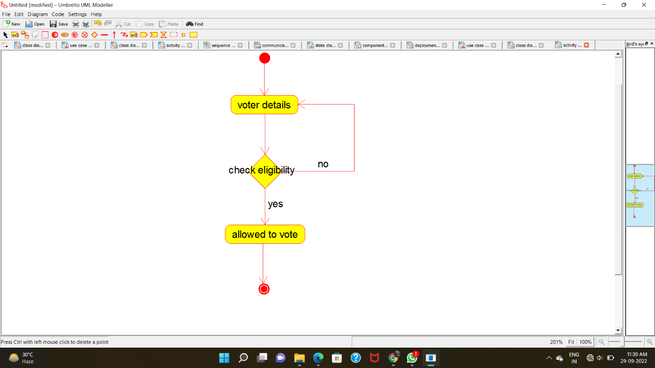

**SEQUENCE DIAGRAM:**

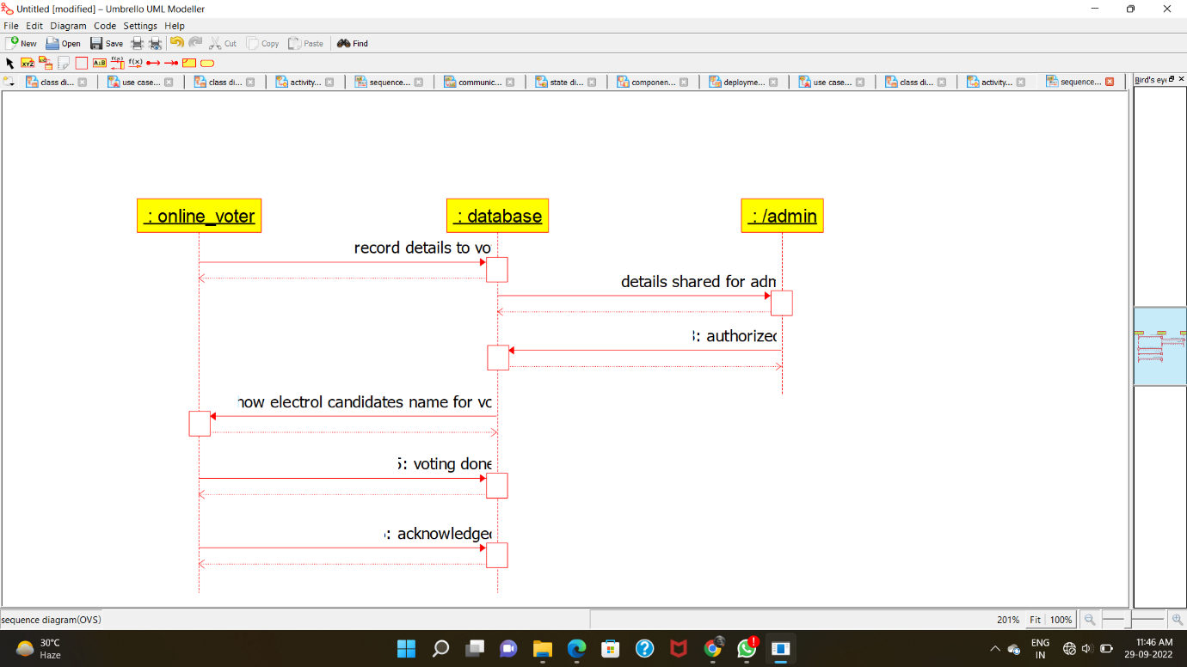

**COLLABORATION DIAGRAM:**

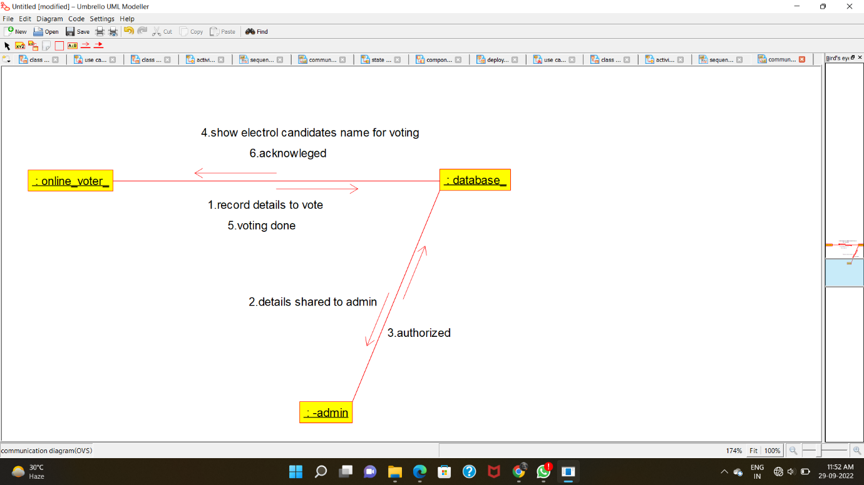

**STATE-CHART DIAGRAM:**

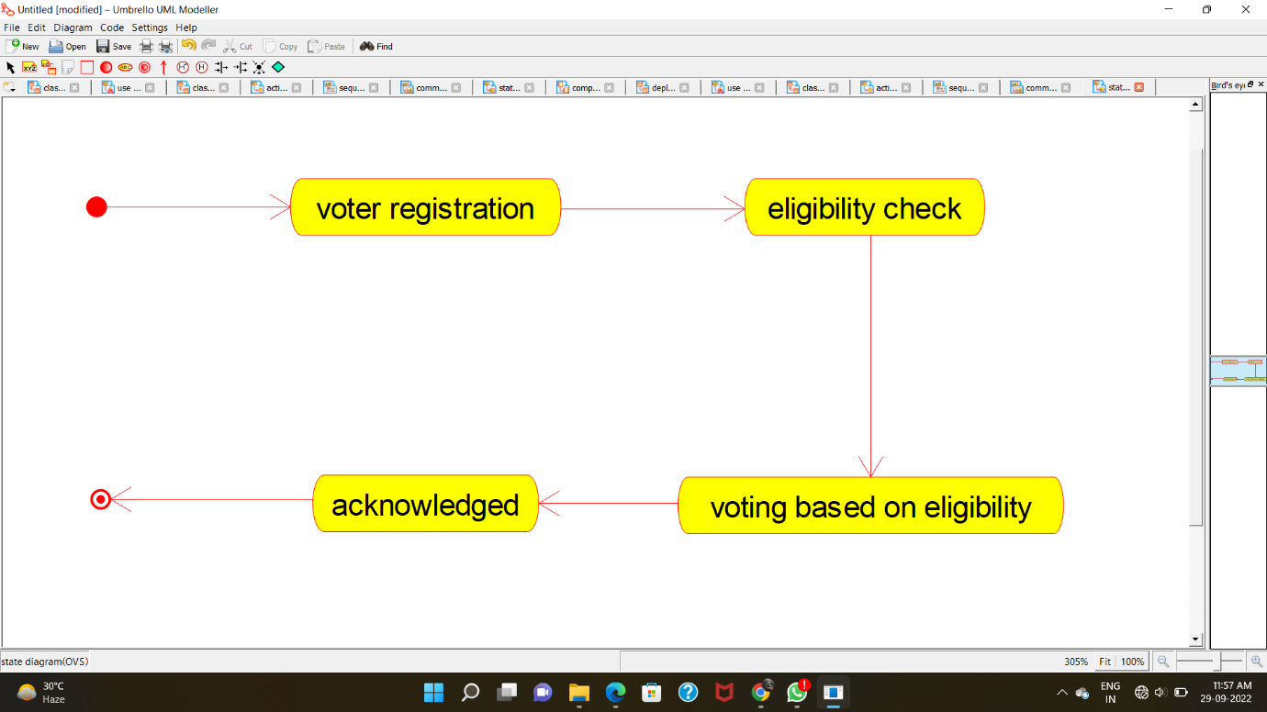

**COMPONENT DIAGRAM:**

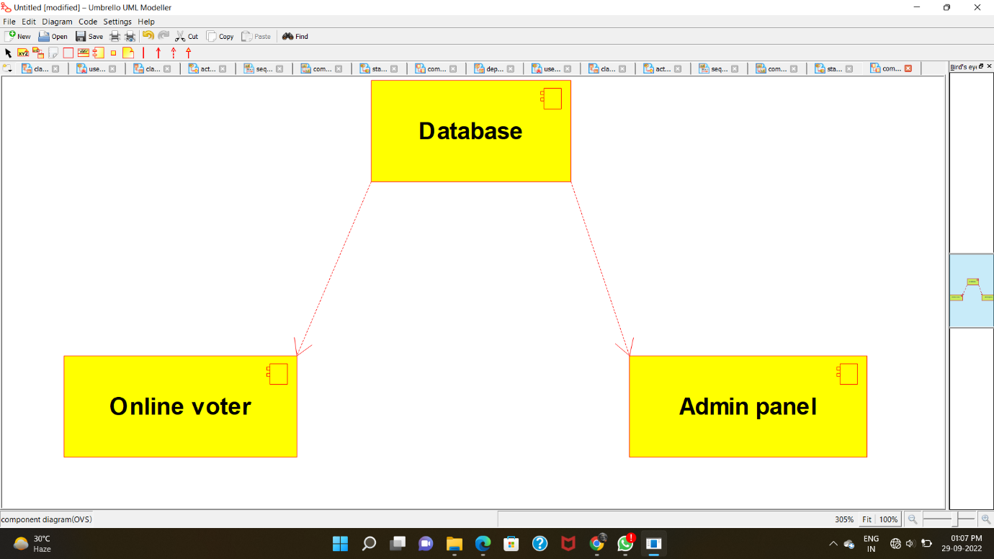

**DEPLOYMENT DIAGRAM:**

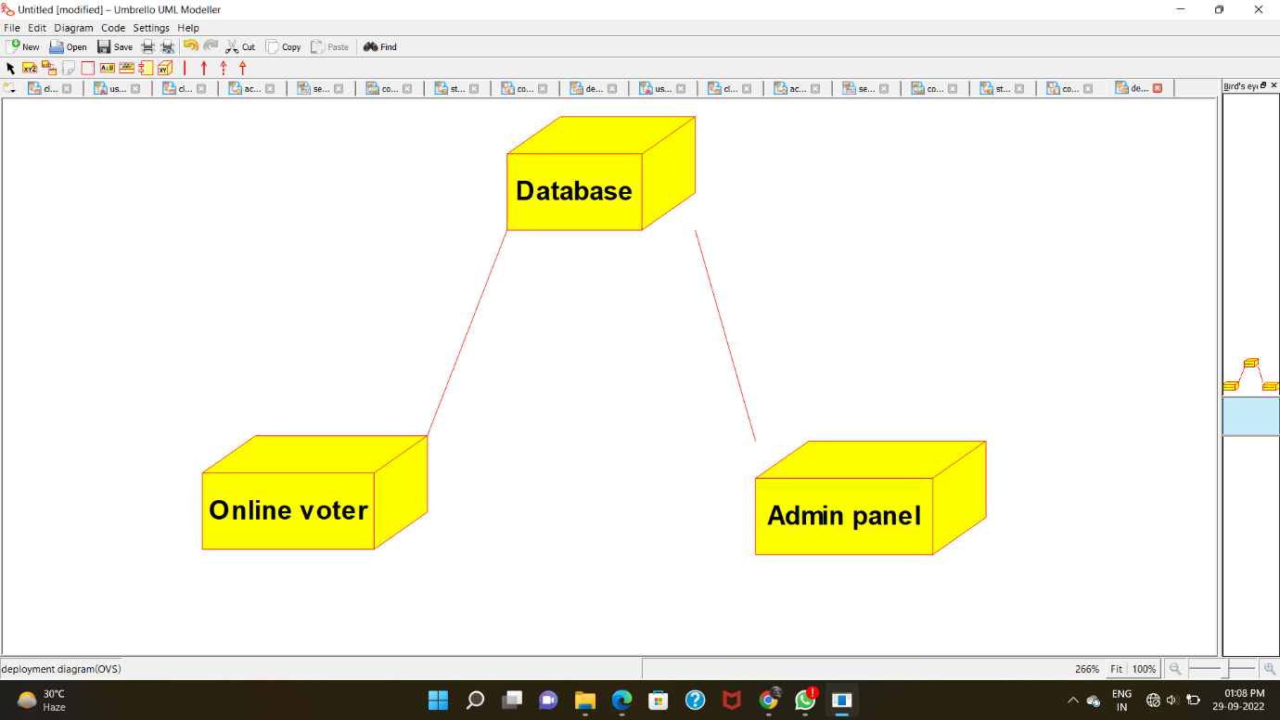

**PROGRAM CODE:**

**CENTRAL DATABASE:**

/**

* Class central_database

*/

public class central_database {

//

// Fields

//

private void voter_details;

private void electoral_details;

private void eligibility_info;

//

// Constructors

//

public central_database () { };

//

// Methods

//

//

// Accessor methods

//

/**

* Set the value of voter_details

* @param newVar the new value of voter_details

*/

private void setVoter_details (void newVar) {

voter_details = newVar;

}

/**

* Get the value of voter_details

* @return the value of voter_details

*/

private void getVoter_details () {

return voter_details;

}

/**

* Set the value of electoral_details

* @param newVar the new value of electoral_details

*/

private void setElectoral_details (void newVar) {

electoral_details = newVar;

}

/**

* Get the value of electoral_details

* @return the value of electoral_details

*/

private void getElectoral_details () {

return electoral_details;

}

/**

* Set the value of eligibility_info

* @param newVar the new value of eligibility_info

*/

private void setEligibility_info (void newVar) {

eligibility_info = newVar;

}

/**

* Get the value of eligibility_info

* @return the value of eligibility_info

*/

private void getEligibility_info () {

return eligibility_info;

}

//

// Other methods

//

/**

*/

public void get_voter_details()

{

}

/**

*/

public void display_candidate_info()

{

}

/**

*/

public void record_eligibility_permit()

{

}

ONLINE VOTER:

/**

* Class online_voter

*/

public class online_voter {

//

// Fields

//

private void details;

private void cast_vote;

//

// Constructors

//

public online_voter () { };

//

// Methods

//

//

// Accessor methods

//

/**

* Set the value of details

* @param newVar the new value of details

*/

private void setDetails (void newVar) {

details = newVar;

}

/**

* Get the value of details

* @return the value of details

*/

private void getDetails () {

return details;

}

/**

* Set the value of cast_vote

* @param newVar the new value of cast_vote

*/

private void setCast_vote (void newVar) {

cast_vote = newVar;

}

/**

* Get the value of cast_vote

* @return the value of cast_vote

*/

private void getCast_vote () {

return cast_vote;

}

//

// Other methods

//

/**

*/

public void share_the_details()

{

}

/**

*/

public void cast_the_vote_for_favorite_party()

{

}

}

ADMIN:

/**

* Class admin_

*/

public class admin_ {

//

// Fields

//

private void collect_details;

private void check_eligibility;

//

// Constructors

//

public admin_ () { };

//

// Methods

//

//

// Accessor methods

//

/**

* Set the value of collect_details

* @param newVar the new value of collect_details

*/

private void setCollect_details (void newVar) {

collect_details = newVar;

}

/**

* Get the value of collect_details

* @return the value of collect_details

*/

private void getCollect_details () {

return collect_details;

}

/**

* Set the value of check_eligibility

* @param newVar the new value of check_eligibility

*/

private void setCheck_eligibility (void newVar) {

check_eligibility = newVar;

}

/**

* Get the value of check_eligibility

* @return the value of check_eligibility

*/

private void getCheck_eligibility () {

return check_eligibility;

}

//

// Other methods

//

/**

*/

public void get_the_details()

{

}

/**

*/

public void check_the_eligibility_and_permit()

{

}

}